California Institute of the Arts  
  
  
  
  
  
  
 Meatbags and Machines  
Realizing Relations Between Humans and Mechatronics

by

Eric Heep

A thesis submitted in partial fulfillment for

the degree of Master of Fine Arts

in the

Herb Alpert School of Music

Music Technology: Interaction, Intelligence & Design

Supervisory Committee

Dr. Ajay Kapur

**Mentor**

Dr. Owen Vallis

**Committee**

Mr. Scott Cazan

**Committee**

Abstract

This research serves to the illustrate methods that are used to infuse a human element into the mechatronic art presented in this thesis. In this art, there is an attempt to create a relationship between the performer and the mechatronics or the audience and the mechatronics. This relationship allows the art to develop a dialogue between the mechatronic and the humans involved. The creation of this relationship, and the transference to its audience, is investigated in this thesis.

This research posits that the implementation of certain characteristics allows for this type of relationship to be created; those being a sonic characteristic, a procedural characteristic, and a systemic characteristic. These characteristics are germane to the tradition of experimental music. Through the use of these characteristics, a theoretical *magic trick* can be formed which allows a transference of this relationship to the audience. The art in this thesis also resists the ‘lure of technological glitter,’ meaning that novel uses of familiar technology are preferred over familiar uses of novel technology.

The conclusions reached state the successes and failures of the individual pieces, and continue to describe the subsequent work which implements or will implement similar methods to those found in this thesis.

Acknowledgments

I’d like to thank the following for their support and inspiration throughout my time at CalArts.

Will fill out after the first draft is accepted.

Contents

Abstract 3

Acknowledgments 4

Contents 5

List of Figures 7

Chapter 1 Introduction 9

1.1 Technology is a Glittering Lure 9

1.2 Motivation 10

1.3 Characteristics 11

1.3.1 Sonic Characteristic // Noise 12

1.3.2 Procedural Characteristic // Physical Narrative 12

1.3.3 Systemic Characteristic // Complexity & Emergence 13

1.3.4 Summary 14

1.4 Outline 14

Chapter 2 Historical Context 17

2.1 Sonic Heritage 17

2.1.1 Mechatronic Sound-Objects and Musical Robotics 17

2.1.2 Noise 20

2.2 Compositional Heritage 23

2.2.1 Processes // Physical Narrative 23

2.2.2 Systems // Complexity & Emergence 25

Chapter 3 Mechatronic Performance // Animal 27

3.1 The Odradek 27

3.2 Technological Implementation 29

3.2.1 Design // Construction 29

3.2.2 Meepo // Arduino 30

3.2.3 ChucK 31

3.3 Discussion 31

3.3.1 Characteristics 32

3.3.2 Pitch 33

Chapter 4 Mechatronic Installation // Red Mitsubishi 36

4.1 The Grid’s Heart Fluttered 36

4.2 Technological Implementation 39

4.2.1 Design // Construction 39

4.2.2 Meepo // Arduino 40

4.3 Discussion 41

4.3.1 Characteristics 42

4.3.2 Pitch 43

Chapter 5 Mechatronic Performance // Beast 47

5.1 A Fertile Ground 47

5.2 Technological Implementation 51

5.2.1 ChucK // Markov Chains 51

5.2.2 Design // Space 54

5.3 Discussion 54

5.3.1 Characteristics 54

5.3.2 Pitch 56

Chapter 6 Conclusion 61

6.1 Introduction 61

6.2 Primary Contributions 61

6.3 Subsequent and Future Work 62

*6.3.1* *Working On My Thesis* 62

6.3.2 *Kill* *the Magic* 63

6.3.3 *Meatbag* 64

6.3.4 Future Work 65

6.4 Final Thoughts 66

Bibliography 67

List of Figures

Figure 1. The three characteristics found in the work presented in this thesis. 12

Figure 2. Venn diagram showing the three aesthetic characteristics described in this thesis, and how they influence the three pieces that are discussed in this thesis. 15

Figure 3. Singer's GuitarBot on the left, Kapur and Michael Darling's NotomotoN on the right. 18

Figure 4. Trimpin's *Klompen.* 18

Figure 5. Zimoun and Hannes Zweifel’s *20 prepared dc-motors, 81 cardboard boxes 70x70x70cm* 19

Figure 6. Mo Zareei adjusting *RASPER* on the left, and *MUTOR* on the right, his mechatronic sound-objects. 19

Figure 7. A rotary solenoid, a push-pull solenoid, and a contact microphone sealed in plastic coating. 21

Figure 8. The mechatronic sculpture on the left, and the setup for Animal on the right. 28

Figure 9. AutoCAD DXF outline of the CNC cut on the left, and the completed cut on the right. 29

Figure 10. Meepo Altium design, and the board populated and acting as a shield for an Arduino Uno. 30

Figure 11. Dota's Meepo. 31

Figure 12. Example of the ChucK code found in Animal, the function names describe the narrative and act as sections of the piece. Within each function is a set of processes that make up its procedure. 32

Figure 13. The first Angel in Neon Genesis Evangelion (Sachiel) alongside Animal. 33

Figure 14. Animal during performance, with the object in the forefront while the performer takes a photo from the back. 34

Figure 15. Red Mitsubishi installed in the WaveCave at CalArts. 37

Figure 16. The original totaled Red Mitsubishi, after the accident on Interstate-5. 38

Figure 17. Draft of the initial fixture design alongside its final implementation. 40

Figure 18. Power supply and Meepo/Arduino combo, one of the nodes that controls six of the solenoids. 41

Figure 19. A retired solenoid and the pieces that comprised its mechanism lying beneath it. 42

Figure 20. Me repairing one of the broken solenoids on the left (and meddling with the conceptual intent of the installation), and a power cable that allowed one to ‘pull the plug’ on the installation. 43

Figure 21. Yasanao Tone and his "Wounded CD", a compact disc prepared with pieces of tape. 44

Figure 22. Midway through Jonathon Schipper’s *Slow Motion Car Crash.* 45

Figure 23. The setup of *Beast* on the left, a chime resting on a solenoid on the right. 48

Figure 24. *Beast* moments from the ‘kick’, at CalArts Wild Beast performance space. 49

Figure 25. The first row of a transition matrix being created out of a sequence of inputs. 52

Figure 26. Degradation of a Markov chain, until a chain of only ‘B’s exists. 53

Figure 27. *Beast* setup at the CCRMA stage at Stanford, with the space ready for the performer to inhabit. 54

Figure 28. First performance of *Beast* on the left, second performance on the right (the performer soldering on stage). 55

Figure 29. *Beast* and the international symbol for nuclear disarmament (peace symbol), along with the symbol for ionizing radiation (nuclear symbol). 58

Figure 30. A photograph of Val Verde, filtered and resized by a Processing sketch. 62

Figure 31. Puck PCB, allows control of 16 RGB LEDs, (also named after a Dota character). 63

Figure 32. *Kill the Magic,* performed during ESP night at CalArts in the ROD. 64

Figure 33. *Meatbag*, performed at the wulf with Amy Golden. 65

# Introduction

*“Well, technology is a glittering lure. But, uh, there is the rare occasion when the public can be engaged on a level beyond flash, if they have a sentimental bond with the product.*

*My first job, I was in-house at a fur company, with this old-pro copywriter, a Greek named Teddy. Teddy told me the most important idea in advertising is new. Creates an itch. You simply put your product in there as a kind of calamine lotion. But he also talked about a deeper bond with the product. Nostalgia. It’s delicate, but potent (..)*

*Teddy told me that in Greek, “nostalgia” literally means “the pain from an old wound”. It’s a twinge in your heart far more powerful than memory alone. This device isn’t a spaceship, it’s a time machine. It goes backwards, forwards, takes us to a place where we ache to go again. It’s not called the wheel. It’s called the carousel. It lets us travel the way a child travels. Round and around, and back home again, to a place where we know we are loved.”*

* Mathew Weiner, *Mad Men[1]*

## Technology is a Glittering Lure

Don Draper is an ad man, and his job is to create an advertising strategy that will sell the most product for his client. Kodak has enlisted Don’s firm to come up with an advertising strategy, they want something space-age and futuristic that will broaden the appeal of their new rotating slide projector. The creative team at Kodak came up with an initial pitch; they suggested calling their slide projector, *The* *Wheel*; they wanted the name to reflect the technological advancements made by Kodak company in creating the projector.

Draper, in response, delivers a pitch that resists the lure of “technological glitter.” His strategy instead deals with the human connection already be found in a machine whose purpose is to revisit memories. As he scrolls through slides of his family, Don shows how the device contains an inherent emotional significance. He remarks that the “device isn’t a spaceship, it’s a time machine,” that allows us to travel back “to a place where know we are loved.”

Instead of *The Wheel*, Draper names it *The Carousel*. He names it so because of the nostalgic twinge the image would elicit from a group of middle-aged businessmen living in the late 1950s. Through Draper’s pitch, he manifests a sentimental context for the slide projector; he transformed a technological marvel into treasure of sentimental worth. Of course, it’s mostly a rouse.

Todd VanDerWerff, of *The A.V. Club*, remarks that Don’s pitch “is complete and utter hokum, designed solely to provoke an emotional response that will be so undeniable the company will reach up and land business with a firm far larger than it deserves.”[2] And he’s right, this pitch is presented in this thesis because it is a *magic trick* played on the Kodak executives. Don knew that the trick only required the slide projector to be framed in the proper context, that context being one that emphasized emotional value rather than futuristic promise.

## Motivation

“*I like novel uses of familiar tech more than familiar uses of novel tech.”*

* Jenny Odell[3]

Odell remarked this sentiment during her presentation at the Eyeo 2016 creative coding festival. This idea rings true to the ethos of this thesis, which outlines the major works I’ve created during my last six months at the California Institute of the Arts. There isn’t much “novel tech” or “technological glitter” found in these works. Instead, I’m presenting pieces that use a *pitch* (in the *Mad Men* sense) or a *magic trick* that contextualize familiar technology in unexpected ways.

My artistic practice is one that is attempting to infuse a human element into mechatronic sound art. This doesn’t mean that I’m merely attempting to create work that elicits a human response, ideally most art does that. Rather, I’m striving to infuse a non-sterile quality into an artistic discipline that often relies on the lure of ‘technological glitter’ or ‘novel tech.’ Specifically, I’m aiming to create the semblance of a relationship between the mechatronics and the performer (or the audience).

Using electromagnetic solenoids, wood, and metal; I’m attempting to create moments that allow us to recognize human affection or mortality with a material that is often seen as emotionally barren. The goal is to create a framing which utilizes these impassive materials in an effort to draw out a human relationship from the work. The framing here can be considered the *pitch*, or the *magic trick*.

Like most magic, this type focuses around the beguilement of an audience, with the audience participating willingly. While the audience understands that nothing fantastical is taking place, they are still waiting to be tricked. They’re half expecting an illusion that can frustrate the expectations of a piece; some factor that can extend a piece beyond its prescribed limitations. This magicI’m considering is a sleight of hand that belies an audience’s perception of reality; it’s a welcome rouse. And it is not necessarily the trick that is important (as it might be ‘complete and utter hokum’), but instead the resulting effect is important. An epiphany can be materialized that realizes a relationship between the audience and the machines they’re watching. This realization is what allows for moments of affection or sentimentality to be created with these lifeless materials. It’s a method that can make the work more *human*, not in an anthropomorphic sense, but in a relational sense.

## Characteristics

This thesis will describe how such guile can be created within the framework of mechatronic sound art by discussing the methods in which this is attempted. There are three aesthetic attributes found in these pieces that contribute to the creation of these relations. There is a sonic characteristic based on noise, a procedural characteristic based on the concept of a physical narrative, and a systemic characteristic based on the concepts of complexity and emergence.

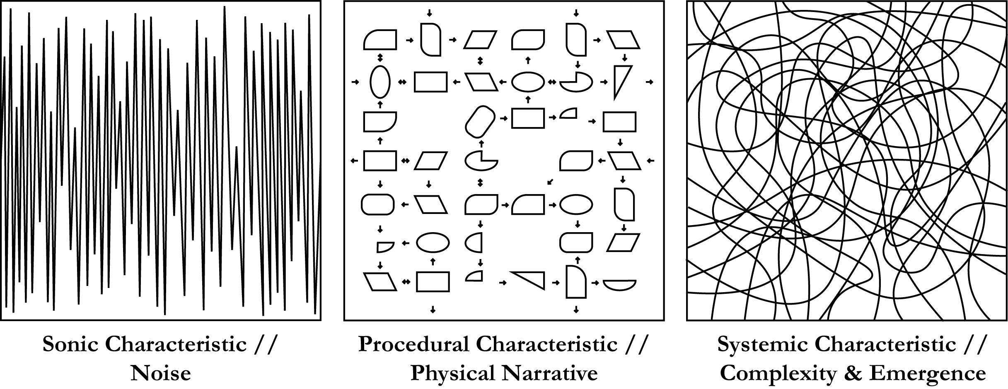

Figure . The three characteristics found in the work presented in this thesis.

### ../noise.pngSonic Characteristic // Noise

Noise is the primary sonic element of these works. This noise is the stuff of machines, the sonic output of everyday objects; this is a noise whose roots stem from the Futurist definition of noise as described by Luigi Russolo. When the term *noise* is used in this thesis, it is describing the sort of noise that arose from the “increasing proliferation of machinery” [4] of the early 20th century. This noise is the sound of machines and human action. An audience has an inherent connection to this type of noise because of its familiarity to everyday experiences, and the discussed pieces will explore this connection.

### ../narrative.pngProcedural Characteristic // Physical Narrative

The compositional method in this thesis requires that the sound produced is ancillary or parallel to a narrative that is developing. In each piece, there is a story being told through a set of human actions and programmable functions; the music that occurs is merely a result of the narrative’s progression.

This method can be considered a type of process music. “In the experimental “open work,” musical arguments are replaced by *processes* that result in “music,” and the writing of music is supplanted by the creation of situations.”[5] Brandon LaBelle is supplanting the typical creation of sound in favor of processes that will determine its output. In the context of this research, the physical narrative posited is progressed by human actions and programmable functions; the physical narrative is the situation that LaBelle is referring to. There is rarely an intentional sound that occurs just for the sake of sound. This does not necessarily give sound less importance in the work; there is still an objective consideration of the sonic landscape that is created, but the resulting sound always coincides with a narrative (or process) that is developing.

In regard to the performed pieces in this thesis, the narrative elicits a task-oriented performance that the performer progresses with human action.

In regard to the installation in this thesis, the physical narrative is subjected to a physical system that is in place. It is progressed by the installation’s nature, rather than human action.

### ../complexity.pngSystemic Characteristic // Complexity & Emergence

The amount of complexity found in the composition is important to the works in this thesis. There is a concept of *emergence*, which describes a system with an amount of complexity which grants that system an unpredictable outcome. This unpredictable output can be seen as an output that *emerges* from the system due to its complexity.

In regard to this performed works in this thesis, this characteristic refers to a complex system that the performer must respond to it as if it were a cooperator. When a system is complex enough, the performer can be genuinely surprised by the mechatronic object’s behavior, which strengthens the semblance of a relationship between the two. A scripted narrative can be created that still allows for surprises during the performance, leaving the performer unaware of the outcome. This allows the performer to be genuinely pleased or frustrated at the mechatronic object’s behavior, giving the object a personality for the performer to respond to.

In regard to the installation in this thesis, this complexity arises from the physical nature of the installation itself. The delicate mechanics fail in unexpected ways, providing an output that is relatable to our reliance on the machines we are dependent on.

### ../narrative.png../noise.png../complexity.pngSummary

The combination of these characteristics work together to create the human relations this research is seeking. In regard to the performative pieces in this thesis (*Animal* and *Beast*), the mechatronics and performer cooperate to progress the narrative of the piece. Ideally, there is a complex system that relies on physical narrative to develop a relationship between the mechatronic object and the performer. These performances will be further described in chapter 3 and chapter 5.

With regard to the mechatronic installation in this thesis *(Red Mitsubishi)*, the mechatronics respond to the fragility of the material itself to form its narrative. The installation’s auto-destructive nature is in fact the narrative of the piece. The audience’s personal association with an object’s failing and its eventual destruction becomes the relational aspect of this work. This will be further described in chapter 4.

The method in which these attributes are mixed and matched contribute to how an audience can be guiled; they are what I’m considering a *pitch*. In all cases, a work is created that utilizes a narrative which requires human action or physical processes to create its sound, the combination of such characteristics creating a vague anthropomorphic theme throughout the different pieces*.* The characteristics and their implementation methods enable this *pitch* to materialize, in efforts of creating a relational bond between the machines (the mechatronics) and meatbags (us).

## Outline

Chapter 2 surveys the historical context for this work based on the characteristics mentioned above. The remaining chapters will discuss the three pieces and how they use these characteristics to realize a *pitch,* or *magic trick*. These chapters will discuss the effectiveness of the characteristics in the work and how various combinations of these attributes allows for a piece to realize a relationship between humans and machines.

For example, *Animal* depends heavily on its narrative procedure and its scrawled and noisy soundscape, but lacks the systemic complexity which would lend the object a personality. In *Red Mitsubishi,* there is no physical performative narrative (as it is an installation), but its physical complexity and acoustic rawness still allow for it to be anthropomorphized. The nature of the solenoids helps build a physical narrative without the necessity of human action. *Beast* contains all three of discussed characteristics, and during its performance realizes a complex and constantly changing relationship between the object and the performer.

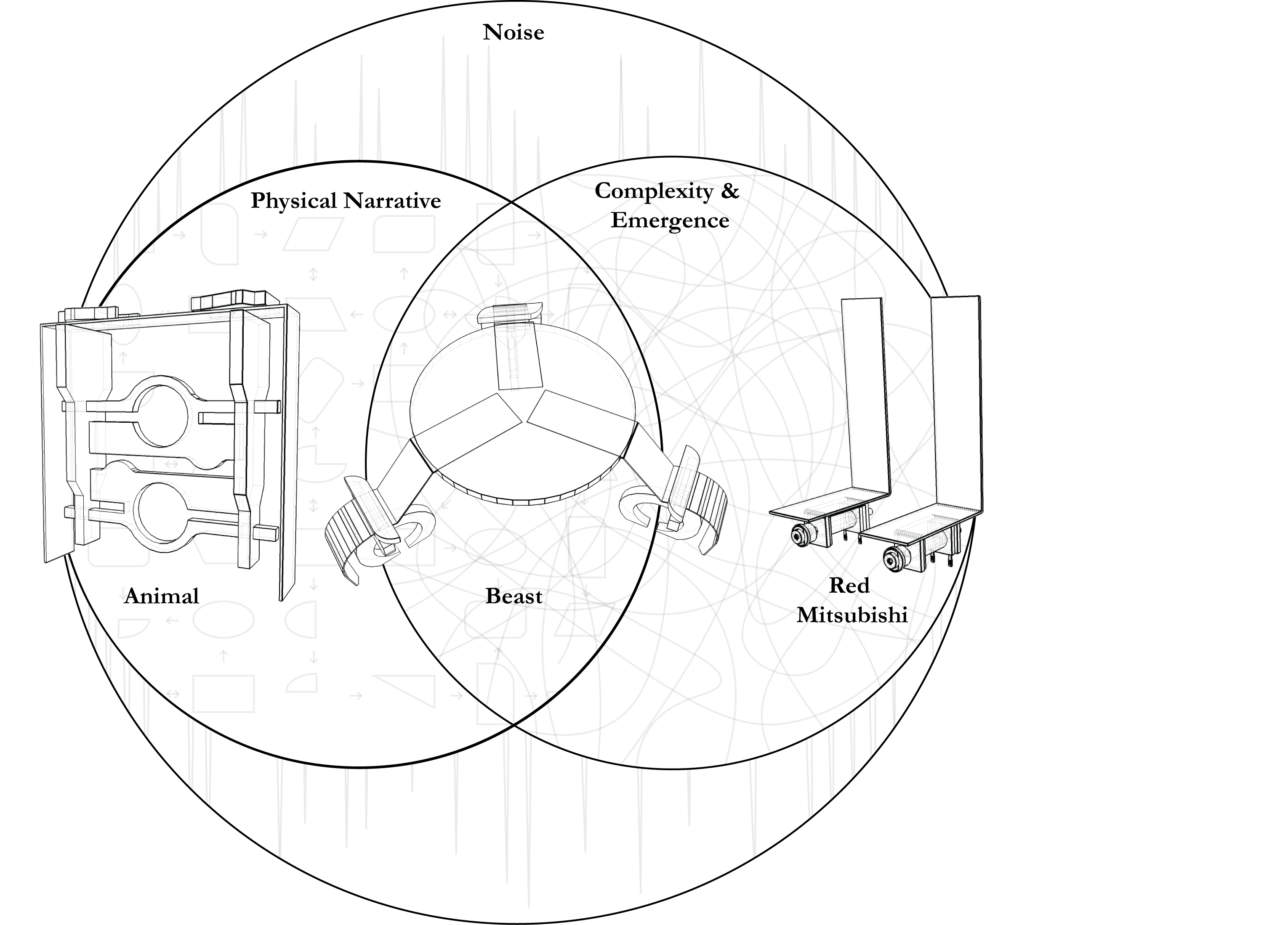

Figure . Venn diagram showing the three aesthetic characteristics described in this thesis, and how they influence the three pieces that are discussed in this thesis.

In any case, these elements merely create moments that make up a larger event. They are methods that contribute to an effective pitch. The pitch mentioned being made up of moments of mortality, or sentimentality, or disobedience; moments that are characteristically non-robotic.

Lastly will be a conclusion presented that discusses the themes of this thesis, as well as the direction of any future work.

# Historical Context

A short history of mechatronic and robotic instruments will be given, as they pertain to the materials used in this research. A discussion on the three characteristics and their historical relevance will then follow.

## Sonic Heritage

As the primary material used in the presented works are mechatronic sound objects, a short history of their use is provided. Then a glance at the origins of noise is provided which posits their connection to everyday life.

### Mechatronic Sound-Objects and Musical Robotics

Mo Zareei describes the different ways that “robotics, mechatronics, and automatic apparatuses”[6] have been used in course of the past decade. Zareei suggests that there have been two different approaches to their integration, and further clarifies the difference between ‘musical robotics’ and ‘mechatronic sound-objects.’

The term “musical robotics” describes the work of artists such as Eric Singer, Ajay Kapur, and Jim Murphy. Singer’s LEMUR (League of Electronic Musical Urban Robotics) sought to “augment the possibilities available to players and composers” in order to provide “compelling new means of musical expression.”[7] The KarmetiK Machine Orchestra utilized an “ensemble of laptop performers and a set of networked robotic idiophones and membranophones,” designed by Kapur and Michael Darling. These musical robots are capable of “performance in areas beyond human performers’ abilities.” A collection of piano robots, turntable robots, percussion robots, string robots, and wind robots are described in Kapur’s article “A History of Robotic Musical Instruments.”[8]

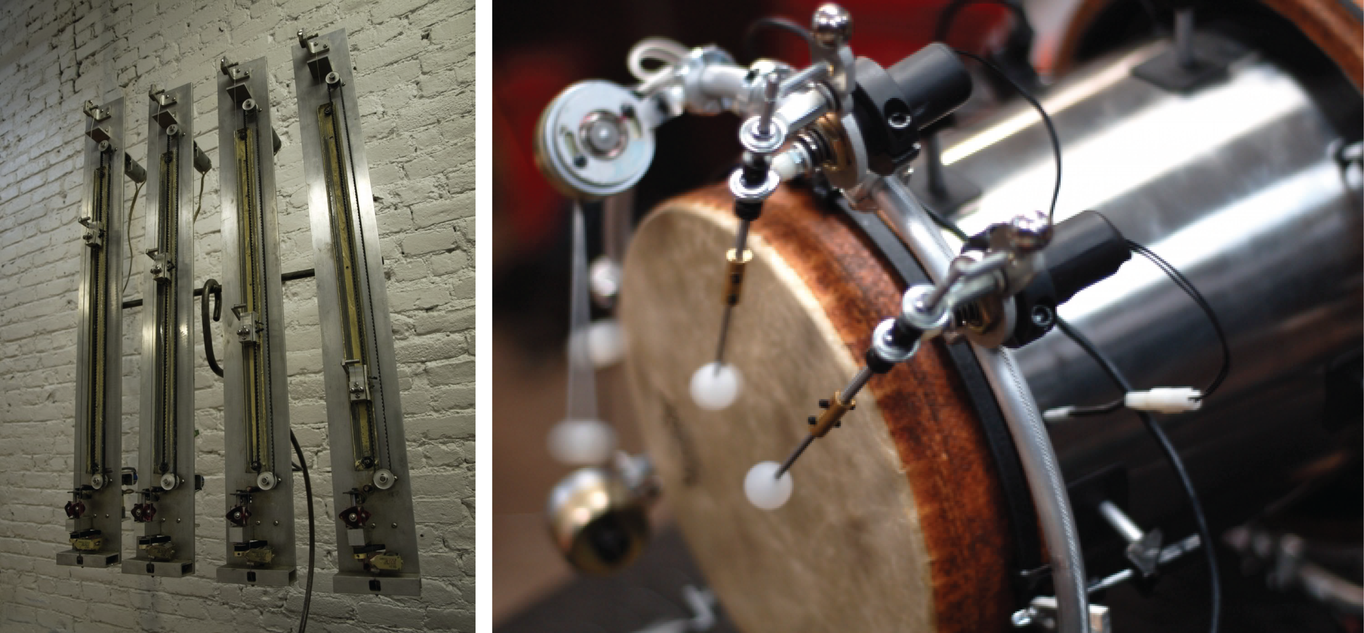

Figure . Singer's GuitarBot on the left, Kapur and Michael Darling's NotomotoN on the right.

The term ‘mechatronic sound-objects’ more closely describes the work in this thesis. A collection of these objects is exemplified in *Klompen,* a kinetic sculpture by German born artist Trimpin. The sculpture consists of “120 Dutch wooden clogs suspended from the ceiling and connect by concealed wires to a computer. Mallets, placed in each of the shoes’ toes, were electromagnetically triggered when a visitor activated the sculpture by dropping quarters into a nearby box.”[9]

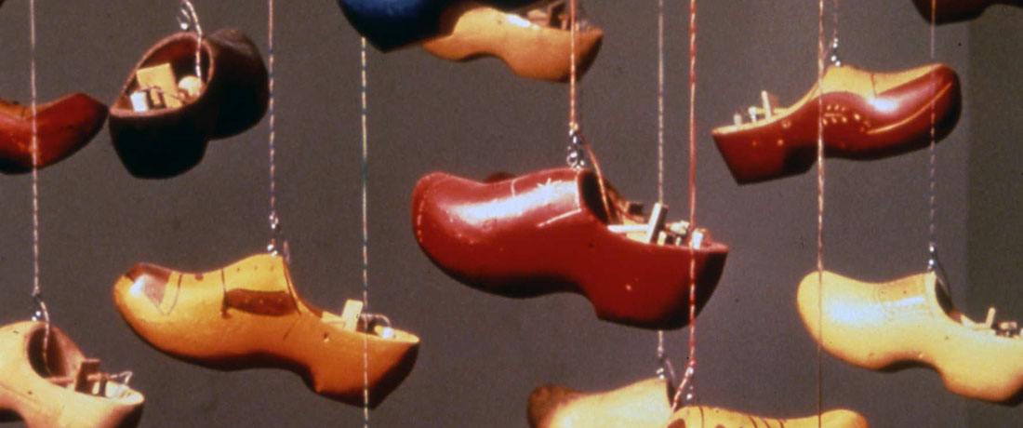

Figure . Trimpin's *Klompen.*

What separates *Klompen* from the realm of robotic instruments is the removal of a robotics that attempts to replace the human performer. Its extra-musical qualities land it into the mechatronic sound-object camp. The mechatronic installations of Swiss artists Zimoun and Pe Lang are comparable, as they create “reductionist sculptures that pare sound-making elements down to their pure forms.”[10]



Figure . Zimoun and Hannes Zweifel’s *20 prepared dc-motors, 81 cardboard boxes 70x70x70cm*

Zareei’s mechatronic sound-object, *RASPER,* aims to “bring the ignored and unwanted noises of the machine back to the domain of aural attention by regulating their irregularity.”[11]

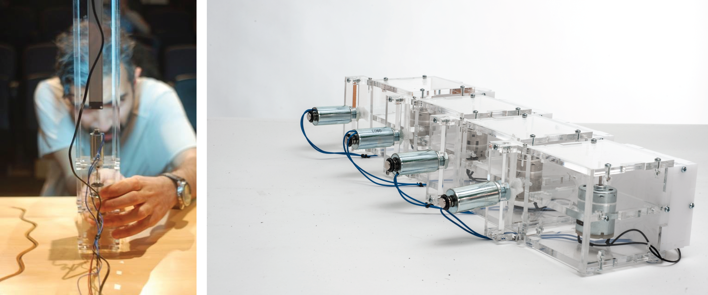

Figure . Mo Zareei adjusting *RASPER* on the left, and *MUTOR* on the right, his mechatronic sound-objects.

Zareei’s components are “held together in an open-faced enclosure made of clear acrylic (…) all the parts, components, and the entire sound generating mechanism are completely visible. In order to boost the audiovisual expressivity.”[12] The work in this thesis also leaves all the components bare, and will be discussed in the following chapters.

### ../noise.pngNoise

*“Sound is all our dreams of music. Noise is music’s dreams of us.”*

* Morton Feldman, *Sound, Noise, Boulez, Varèse[13]*

Feldman here is praising Edgard Varèse’s use of noise in his music, and while he may be waxing poetic, he is still making an interesting observation. Feldman here is positing that we’ve only created music using an idealized sound (“sound is all our dreams of music”), this idealized sound being tones, notes, and all the other sounds that (until then) comprised the tools of traditional music.

Noise on the other hand has always been present in our lives; it is unavoidable and constantly surrounds us. The quote can be paraphrased as such, ‘while we’ve forgotten about (and ignored) noise, noise hasn’t forgotten about us.’ Its enduring presence has tricked us into accepting it as a part of music. The sounds of life eventually had to irk their way into art, as in the case of Varèse. This is why the compositions of Varèse, according to Feldman, give “the impression that the music is writing about mankind rather than being composed.” Varèse is merely accepting noise’s rightful place in music by adopting noise into his compositions. There is something familiar about noise, and noise has an inherent connection to our everyday experiences because of this familiarity. This familiarity is what grants noise a place alongside other music.

The work presented in this thesis draws its sound from either electromagnetic solenoids or human action. This material was chosen because of its non-musical qualities. The solenoids bear a sonic resemblance to the machines we cooperate with every day; the sound of an automatic door unlocking, the sound of a jackhammer at a construction site, the sound of an old car rattling by. The sound of the solenoids used is familiar, but not entirely recognizable.

Contact microphones are also used in this work to amplify the movements of the performer. This allows the physical narrative be to heard as well as seen. These actions become another sonic element whose association escapes traditional music.

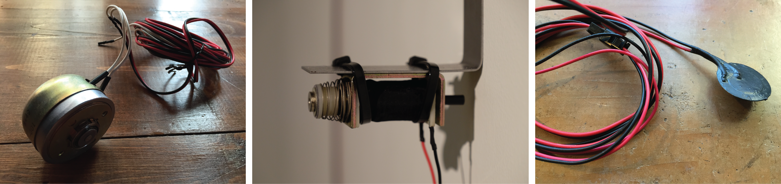

Figure . A rotary solenoid, a push-pull solenoid, and a contact microphone sealed in plastic coating.

We surely have more everyday exposure to these sounds than those that come from traditional music. Does the fact that noise is a prominent audible byproduct of our society insinuate that it can have as much meaningful potential than traditional music? And If so, would that make it meaningful in a different way?

Luigi Russolo, in *The Art of Noises,* supposes the prehistory of musical language and its exclusion of noise.

In this scarcity of *noises*, the first *sounds* that men were able to draw from a pierced reed or a taut string were stupefying, something new and wonderful. (…) Thus was born the idea of sound as something in itself, as different from and independent of life.[14]

Russolo is distinguishing how the sound of music used to be separate from the sound of life; music was placed apart all other sounds because of its “wonder.” He then argues that in music’s evolution, it has sought “combinations that are more dissonant, stranger, and harsher for our ear.” With the proliferation of machines during the 20th century, the call for dissonanc became more profound.

“We must break out of this limited circle of sounds and conquer the infinite variety of noise-sounds.” To Russolo, the incorporation of these complex timbres into traditional music is a natural evolution toward a sublime sonic aesthetic, an aesthetic that is “familiar to our ear and has the power of immediately recalling life itself.” The sound of the cities and the machineries of the time heralded noise’s inclusion into our musical language.

Influenced by the Italian Futurists and the New York City soundscape, Edgard Varèse famously orchestrated a siren to emulate the police of New York in his early work *Amèriques*. Varèse in fact fell in with such artists as “Francis Picabia and Marcel Duchamp, who made art from everyday objects and eroticized the machine.”[15] Art critic Paul Rosenfeld describes this camp of artists as the creators of a “skyscraper mysticism.”

[A] feeling of the unity of life through the forms and expression of industrial civilization, its fierce lights, piercing noises, compact and synthetic textures; a feeling of its immense tension, dynamism, ferocity, and also its fabulous delicacy and precision.[16]

This was the lure of early noise-like music. The sound of the rising cityscapes and the clamor of the industrial revolution were reaching its mechanized zenith, and artists were following in tow. Decades later John Cage, in his *The Future of Music: Credo,* expressed a similar appreciation for this type of noise.

Wherever we are, what we hear is mostly noise. When we ignore it, it disturbs us. When we listen to it, we find it fascinating. The sound of a truck at fifty miles per hour. Static between the stations. Rain. We want to capture and control these sounds, to use them not as sound effects but as musical instruments.[17]

There is a fascination with the sounds of life, and while it may be indescribable, *something* about its familiarity makes it a powerful musical tool. Cage expresses the desire and respect that considers these sounds “musical instruments” and not just “sound effects.” For the context of this thesis, the term *noise* will primarily be referring to this idea. This idea being that noise is everywhere, it is inescapable and ingrained into our lives, and “when we choose to listen to it, we find it fascinating.”

## Compositional Heritage

The compositional practice used to create these works stems from the experimental music of the middle 20th century. Composers like John Cage, Steve Reich, Christian Wolf, and so many others, strayed from controlling the total configuration of a piece, and instead opted to develop a process that would “determine all the note-to-note (sound-to-sound) details and the overall form simultaneously.”[18] These processes were deemed experimental, not because the term is “descriptive of an act to be later judged in terms of success or failure, but simply as of an act the outcome of which is unknown.”[19]

Experimental composers are by and large not concerned with prescribing a defined *time-object* whose materials, structuring, and relationships are calculated and arranged in advance, but are more excited by the prospect of outlining a *situation* in which sound occurs, a *process* of generating action (sounding or otherwise).[20]

The processes used by these composers define a *system,* which in turn describes the processes’ interactions. The system is an overall description of the various ways in which the work develops because of the processes implementation.

### ../narrative.pngProcesses // Physical Narrative

“*As to whether a musical process is realized through live human performance or through some electro-mechanical means is not finally the main issue. One of the most beautiful concerts I ever heard consisted of four composers playing their tapes in a dark hall (a tape is interesting when it’s an interesting tape).”*

* Steve Reich, *Writings About Music[21]*

Reich’s work is foundational in describing compositions that are built on processes. Reich’s *Pendulum Music* utilizes a physical process that “inexorably works itself out,”[22] the process itself being the releasing of microphones which then swing across a collection of speakers.

At the beginning of the performance the performers take hold of the microphones and draw them towards them. Simultaneously the performers release the microphones and as they swing over the speakers a series of feedback pulses is produced. The performers join the audience and when the microphones are still and a continuous feedback is heard they take hold of their microphones again and the piece is over.[23]

This thesis presents a type of process music that relies on human action to create its sound. It is a task-oriented performance that assigns a role to the mechatronic object and the performer. The sound is wholly reliant on the actions of the performer and the object, and the progression of the piece is reliant these actions. Yasunao Tone’s *Catch Water Music* contains similarities to this idea.

Imagine a dance performance that starts with a splash of water from somewhere above, followed by another splash falling in a different direction. A raincoat-clad performer-musician moves about the stage, pursuing shifting gushes of water, which he tries to intercept with a bucket on top of his head.[24]

The sound in *Catch Water Music* is created by the performers’ attempts at catching the falling water. Tone is stationed above, pouring the water onto the stage below “with thrusts of unpredictable direction and timing.” The running footsteps, the falling water, and Tone’s incidental bucket movements are the human actions that create the performances sound.

The performative pieces in this thesis use a similar task-oriented approach, the only difference being that the performer is fulfilling a narrative while performing. The narrative determines the human actions of the performer, which in turn creates the sound. The progression of a prescribed story creates the form and ‘sound-to-sound’ details of the composition in the course of the narrative’s fulfillment. The story, in short, becomes the process. For the purposes of this thesis, the term *physical narrative* will be used to describe the processes found in the work presented.

### ../complexity.pngSystems // Complexity & Emergence

*““I try to find out what’s there—not to make it do what I want, but to release what’s there. The object should teach you what it wants to hear.”*

* David Tudor[25]

The idea of a system in David Tudor’s music describes a complex collection of electronics wired together in an intentionally confusing manner. The circuitry in his pieces was complex enough that it was nearly impossible to predict their output given a known input. This complexity would hinder the system’s predictability, and as a result the output was seen to *emerge* from the system. This emergence describing the truly unexpected nature of a system’s behavior.

David Behrman’s *Runthrough* is an example of this level of complexity. In the piece, two performers crawl through a small tunnel while shining flashlights around the room. Alvin Lucier describes the piece.

One or two players work dials and switches that control various sound generators and modulators while two other players shine small flashlights onto photoresistors housed in tin cans, distributing sounds to four loudspeakers deployed around the concert space. (…) Conceiving this piece as a quasi-improvised performance work, Behrman allowed ample time for the possibilities offered by his circuitry to unfold.

The flashlights from the performers activated a series of photoresistors that in turn activated a collection of analog oscillators, voltage control modulators, and ring modulators. Behrman had created a system that is not only complex in its circuitry, but also in its interactions. The nature in which the performers interacted with the piece promised unexpected results, as Lucier recounts, “there were no scores to follow; the scores were inherent in the circuitry.” This idea of the ‘circuit as the score’ describes a music in which the system must be learned or experimented with in order to produce a result that is unpredictable. Nicolas Collins describes this camp of composers, and their ‘circuit scores.’

Inspired by Tudor (and fellow visionaries such as David Behrman and Gordon Mumma) and aided by the proliferation of the integrated circuit, which combined transistors into functional, Lego-like modules that could be wired up with a bare minimum of engineering skill, a number of composers adopted a working method based on seat-of-the-pants electronic engineering. The circuit-whether built from scratch, a customized commercial device, or store-bought and scrutinized to death-became the score.[26]

Lucier also describes a slew of experimental composers, from Gordon Mumma to James Tenney, as sharing this same “compositional principle; an action or process, set into motion and sustained throughout the course of the work, produces unexpected and complex results.”[27] But also Lucier describes how these composers were discovering ways to relate to the ‘proliferation of machines’ which continued into the middle 20th century.

The neutrality of these structures seemed only to place the performer, and therefore the listener, more firmly in the human situation in which most people found themselves in that burgeoning technological world.[28]

The pieces in this thesis attempts integrate this level type of complexity. In the case of the performative pieces *(Animal* and *Beast)*, the systems involved must be complex enough that the performer cannot fully predict its output. There is a spirit of true improvisation in the pieces, where the object’s emergent *behavior* allows a genuine response from the performer. Instead of merely watching a narrative *unfold*, a narrative *develops* as the performer responds to the whims of system. Overall, the compositional techniques described here lays the groundwork for a system whose goal is to reflect on the ‘burgeoning technological world.’

# ../animal.jpg Mechatronic Performance // Animal

*“I ask myself, to no purpose, what is likely to happen to him? Can he possibly die? Anything that dies has had some kind of aim in life, some kind of activity, which has worn out; but that does not apply to Odradek. Am I to suppose, then, that he will always be rolling down the stairs, with ends of thread trailing after him, right before the feet of my children, and my children's children? He does no harm to anyone that one can see; but the idea that he is likely to survive me I find almost painful”*

* Franz Kafka, *The Cares of a Family Man[29]*

## The Odradek

Kafka’s Odradek is a something of an ontological quandary. The creature is described as a “flat star-shaped spool for thread” who is “extraordinarily nimble” and lurks about the neighborhood. This imaginary being seemingly has no beginning and has no ending, it simply exists without explanation.

The narrator is conflicted by the existence of this unknown creature who has no explainable origin. By stumbling upon this creature, the narrator forced to ponder his own existence. “Am I to suppose, then, that he will always be rolling down the stairs, with ends of thread trailing after him, right before the feet of my children, and my children’s children?” How would we react when confronted with a mysterious creature that seemingly has no origin and no death? This first piece in this thesis presents a similar set of questions, and aims at creating an unnatural feeling that is akin to the one found in Odradek.

*Animal* is a mechatronic performance that is comprised of a performer and a responsive sculpture. This sculpture was built to possess an uncanny aura, with the performer playing a role that is akin to the aforementioned narrator.

The piece begins when the performer walks up to an old wooden table and turns on a small lamp, the light shines on a diminutive puzzle-like sculpture made out of wood and steel. The object stands as if had always been there, and alongside it is an open computer and a few quarter-inch audio cables hanging off of the nearby lamp.

This is the framing for *Animal*, it’s a narrative that invites speculation. In this setting, it’s required that the performer play the role of a scientist. The lamp, the computer, and the table are also part of this narrative; they’re scenic elements that describe a type of laboratory, with the audience given full view of the experiment. The audience is witnessing the process of the subject and object cooperating with each other for the first time.

The performer carefully grabs one of the hanging quarter inch cables and plugs it into the mechatronic sculpture, and the object responds by humming to life. The insertion of the audio cables being the object’s introduction into a system.

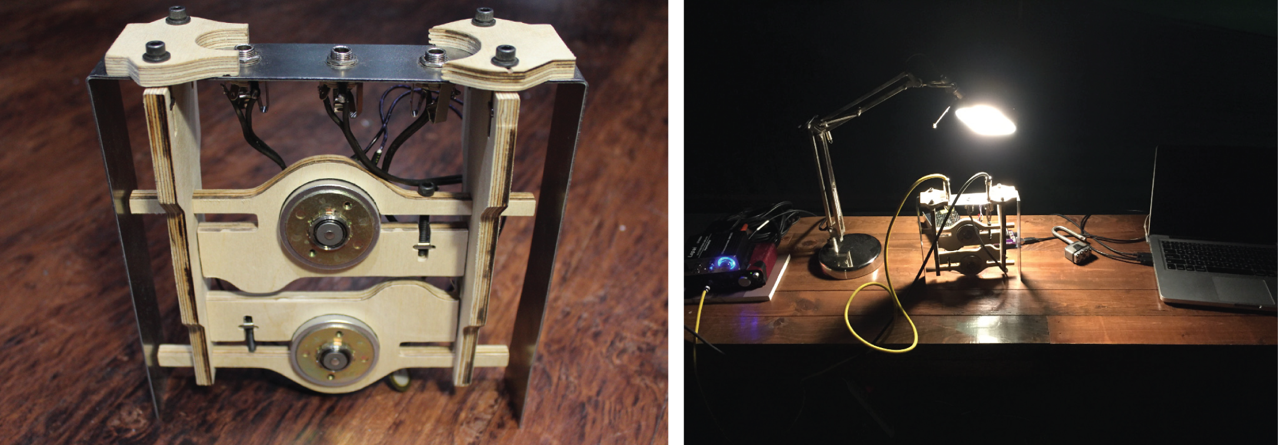

Figure . The mechatronic sculpture on the left, and the setup for Animal on the right.

This humming is emanating from the two solenoids, which act jointly as the heart of the object. The solenoids progress through a series of patterns, their actions amplified by two contact microphones affixed to the wooden fixtures (which themselves are connected to the input jacks). After a period of rapid and repeated actuations, the performer unplugs the two quarter-inch cables from the object. The object begins whirring down until silent, as if its heart valves were disconnected. Then after a stillness, it begins shaking violently, regardless of its severed ties from system. The object is acting on its own and without the energy that brought it to life in the first place. Eventually the object becomes still and the performer turns off the lamp, ending the piece.

## Technological Implementation

All the work in this thesis was created using similar methods; their implementation being a healthy mixture of different technologies. This piece involves CNC (Computer Numerical Control) cutting, PCB (Printed Circuit Board) manufacturing, Arduino programming, and ChucK programming.

### Design // Construction

The sculpture is comprised of cold rolled steel and Baltic Birch plywood. The Baltic Birch fixtures are meant to house the solenoids and grip tightly to the steel frame. A decision was made to use a CNC router as opposed to a 3D printer because the fixtures would have to withstand the rapid vibrations of the solenoids. Wood has a natural pliability that allows for such vibrations, whereas plastic would most likely crack from the stress. These fixtures were designed in Adobe Illustrator.

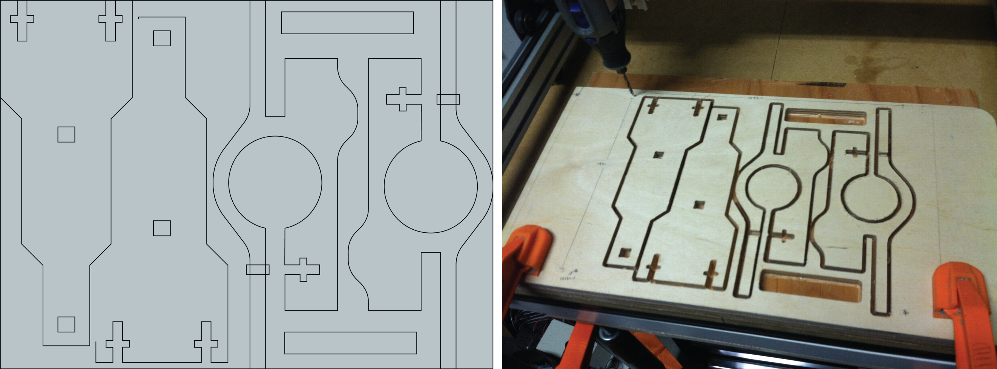

Figure . AutoCAD DXF outline of the CNC cut on the left, and the completed cut on the right.

The steel housing for the fixtures was cut, punched, and bent in the CalArts Super Shop. The CNC cut was designed to fit snugly onto the steel support so that the entire object would vibrate when the solenoids actuated.

The design of the object was meant to be vaguely anthropomorphic, but still puzzling. In fact, the parts do fit together in a puzzle-like manner; and the position of the solenoids in the center of the structure implies the two hearts of an imaginary being.

### Meepo // Arduino

Meepo is a custom printed circuit board that allows for six high voltage signals to be controlled by an Arduino Uno. Activating a pin on the Arduino sends a 5V signal to a MOSFET transistor, which allows a power supply to send a more powerful signal to a solenoid. The solenoids used in Animal require a 24V signal, and thus a 24V power supply is used in conjunction with Meepo.

The board was designed in the PCB designer software, Altium, and then the design was sent to OSH Park, a community printed circuit board manufacturer. The board fits directly over an Arduino Uno, acting as a shield. The PCB was designed with the consideration for use beyond Animal, as its small footprint and moderate solenoid count make it ideal for smaller mechatronic projects.

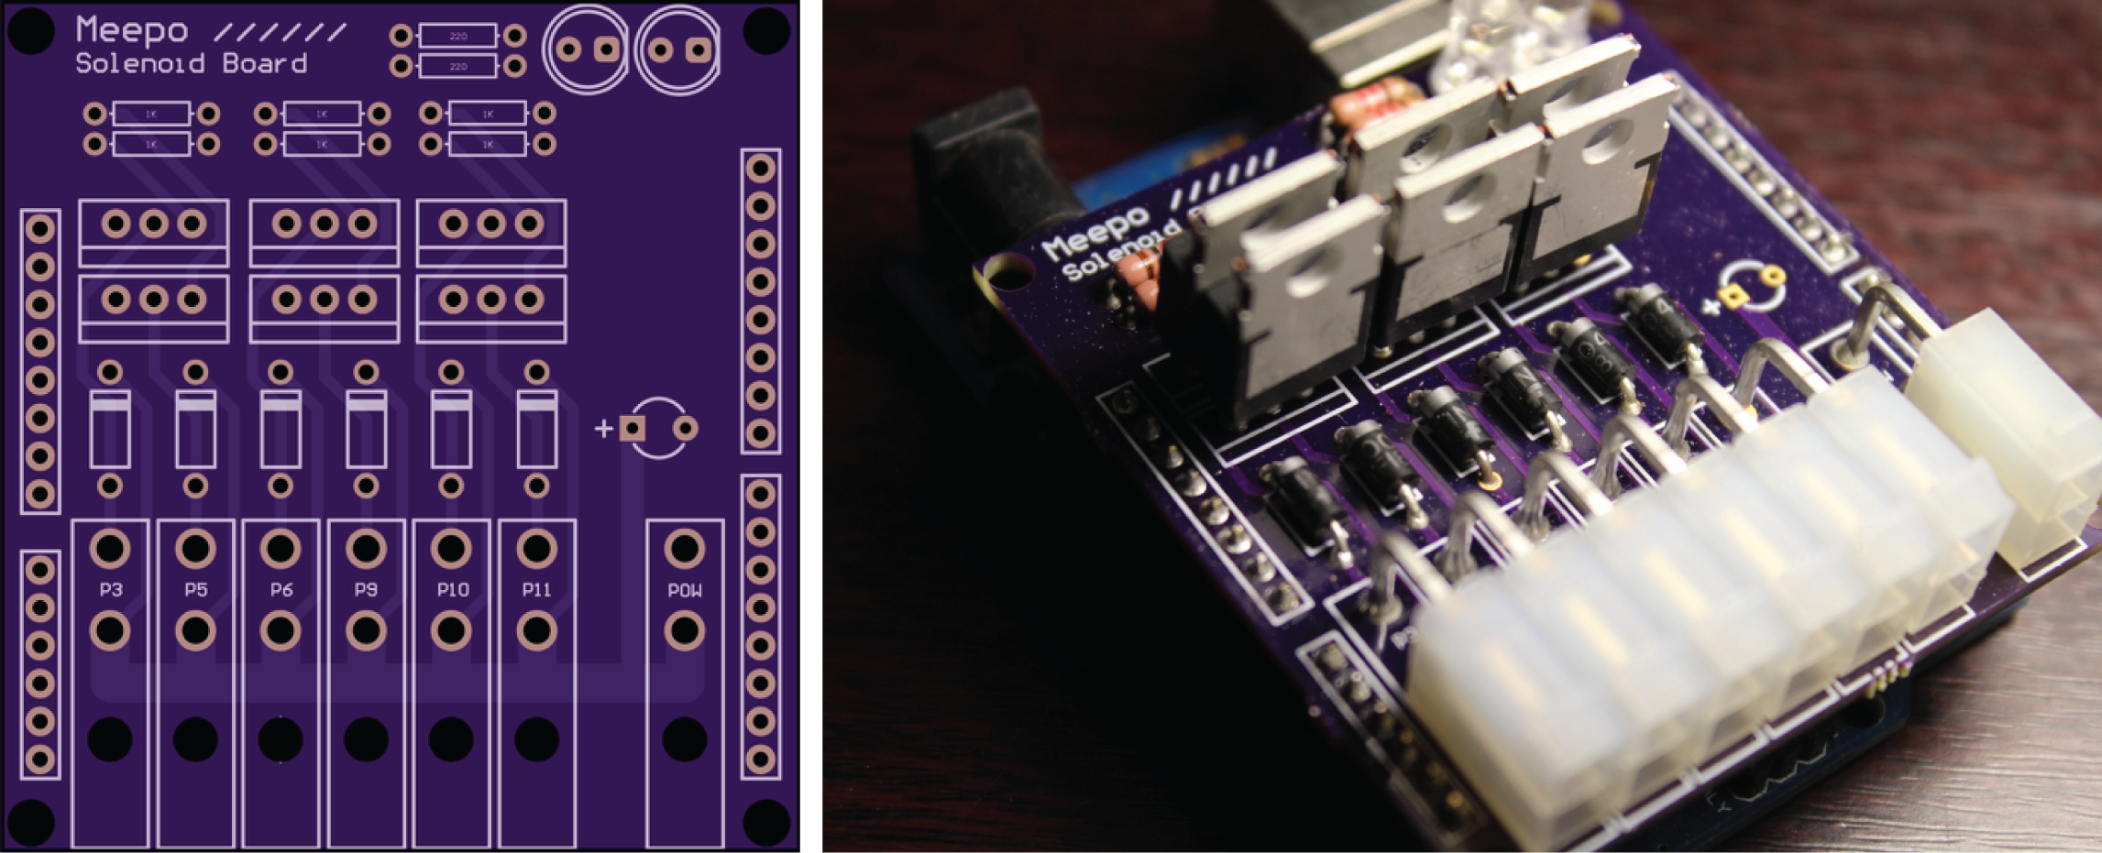

Figure . Meepo Altium design, and the board populated and acting as a shield for an Arduino Uno.

Meepo takes its name from a character in the Valve videogame, Dota. In Dota lore, the character Meepo has several clones which all act together to bring down their enemy with a pickaxe. By no coincidence, the sonic characteristic (and imagery) of multiple Meepos striking their pickaxes against an enemy is similar to the sound of several solenoids actuating simultaneously.



Figure . Dota's Meepo.

### ChucK

ChucK, a real-time sound synthesis programming language was used for the figurative brains of *Animal*. ChucK is an ideal software for this use, as its flexibility allows for the creation an extremely personalized interface. In the context of *Animal,* it allowed me to build a single framework that for allowed mechatronic control and real-time audio analysis. Using envelope following, *Animal* is able to detect whether an audio signal is present or not. This is an important factor in realizing a physical narrative, which will be discussed in the next chapter.

## ../noise.png../narrative.png../complexity.pngDiscussion

This section will discuss how the implementation of the aesthetic characteristics mentioned in introductory chapter affect the realization of a relationship between the object and performer. This thesis does not posit that this is the only method in which this goal can be attained, rather it is focusing on the common attributes of the three works presented in this research. It will be further discussed how their implementation aids in a successful *pitch,* which in the context of this thesis, can grant the audience the ability to relate to the connection present between the object and performer.

### Characteristics

Of the three characteristics previously outlined, only the sonic and procedural characteristic have a strong presence in *Animal.* A set of functions were written that respond to the sonic presence of an audio cable, which allows for a physical narrative to be constructed between the object and the performer during the piece.

For example, the ChucK code that comprises the logic of the Animal is made up of a combination of processes that depend on the performer’s interaction. The bloodFlow() function describes the first stage of the story, which is called after the audio cables have been inserted into the object. This function itself is made up of a number of chance determined process which varies the solenoids actuations according to a range of randomly generated numbers. These processes make up a storied procedure that is both dependent on human action and creates a chaotic soundscape; but these processes are also predictable to the performer.

The lack of complexity in *Animal* which denies a strong connection between the object and the performer. There may be random processes occurring, but the performer is always in control. While a sense of a relation between the object and performer can exist, there is a genuine reaction that is absent from the performance, denying any true improvisation between the object and the subject.

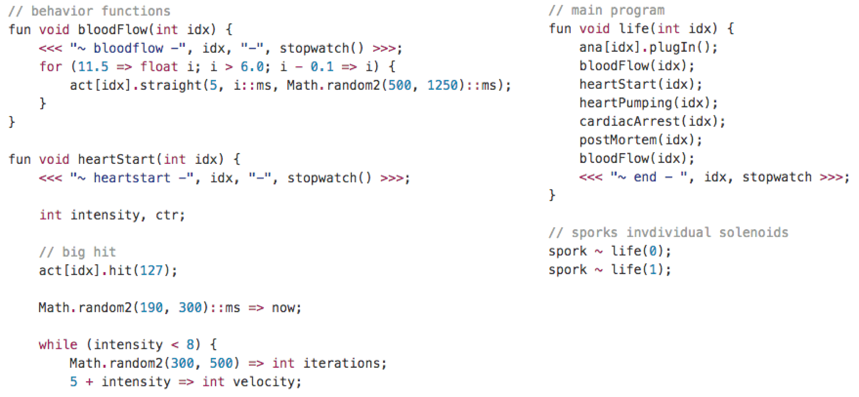

Figure . Example of the ChucK code found in Animal, the function names describe the narrative and act as sections of the piece. Within each function is a set of processes that make up its procedure.

Despite its lack of systemic complexity, the physical actions in *Animal* still create a relationship between the performer and the object. The performer can seemingly activate and deactivate the object by controlling its connection to the system, which allows for a moment of disobedience when the object decides to actuate regardless of its exclusion from the system. The object is granted greater agency both by its violation of the system’s rules and by breaking free from the dependence of its creator.

### Pitch

The sculpture eerily resembles an “Angel” from the Japanese anime, *Neon Genesis Evangelion*. In *Evangelion*, Earth is being attacked by a series of giant, alien-like beings, called Angels. The survivors of Tokyo-3 must defend their city against these Angels with their own giant bio-machines, which they call Evas. The Evas only function by being piloted by a select group of teenager chosen to pilots the Evas. In the shows unfolding plot, it’s learned that the Evas house the souls of the pilot’s mother. This familial connection is necessary to the Evas functionality, and furthermore to Tokyo-3’s protection.

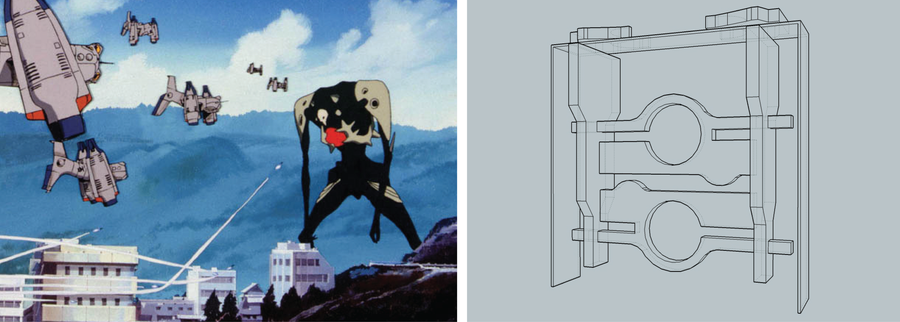

Figure . The first Angel in Neon Genesis Evangelion (Sachiel) alongside Animal.

Though not familial, there is a similar connection that *Animal* is attempting to expose between the performer and the object. *Animal* is exploring the covert but interstitial nature of two seemingly disparate beings. I associate *Animal* with *Evangelion* because in both settings there is this ludicrous notion that humans have the ability to infuse a soul into a machine. At the onset of *Animal,* we’re presented with a sculpture that was evidently created by the artist. The performer is playing the role of the creator, in a *Frankenstein*-like laboratory setting. From that point, it’s up the narrative to convince the audience that there is more to the sculpture than wood and metal. The narrative and design posits an unspoken association, that something uncanny exists between the two.

“The whole thing looks senseless enough, but in its own way perfectly finished,” Kafka describes the Odradek. And indeed, in *Animal,* it does describe the presentation of an object with seemingly no purpose. All the object does is vibrate senselessly at the spurning of its cooperator. But maybe that’s the relation that I’m trying to discover; what do two humans in a relationship actually do other than open their mouths and occasionally smash up against each other? During the performance, the solenoids merely sputter about while the performer occasionally smashes a cable into the input jacks.

The typical object-subject hierarchy of the human and the machine is skewed by the necessity of *Animal’s* cooperation. The object depends on the performer as much as the performer does the object. By putting the sculpture on a similar level as the performer, is the machine being elevated? Is the performer being disgraced? Maybe in the context of performance, there is value in treating a machine with the same regard as a human. Maybe that equalization raises the possibility of something relationship-like existing between the two.

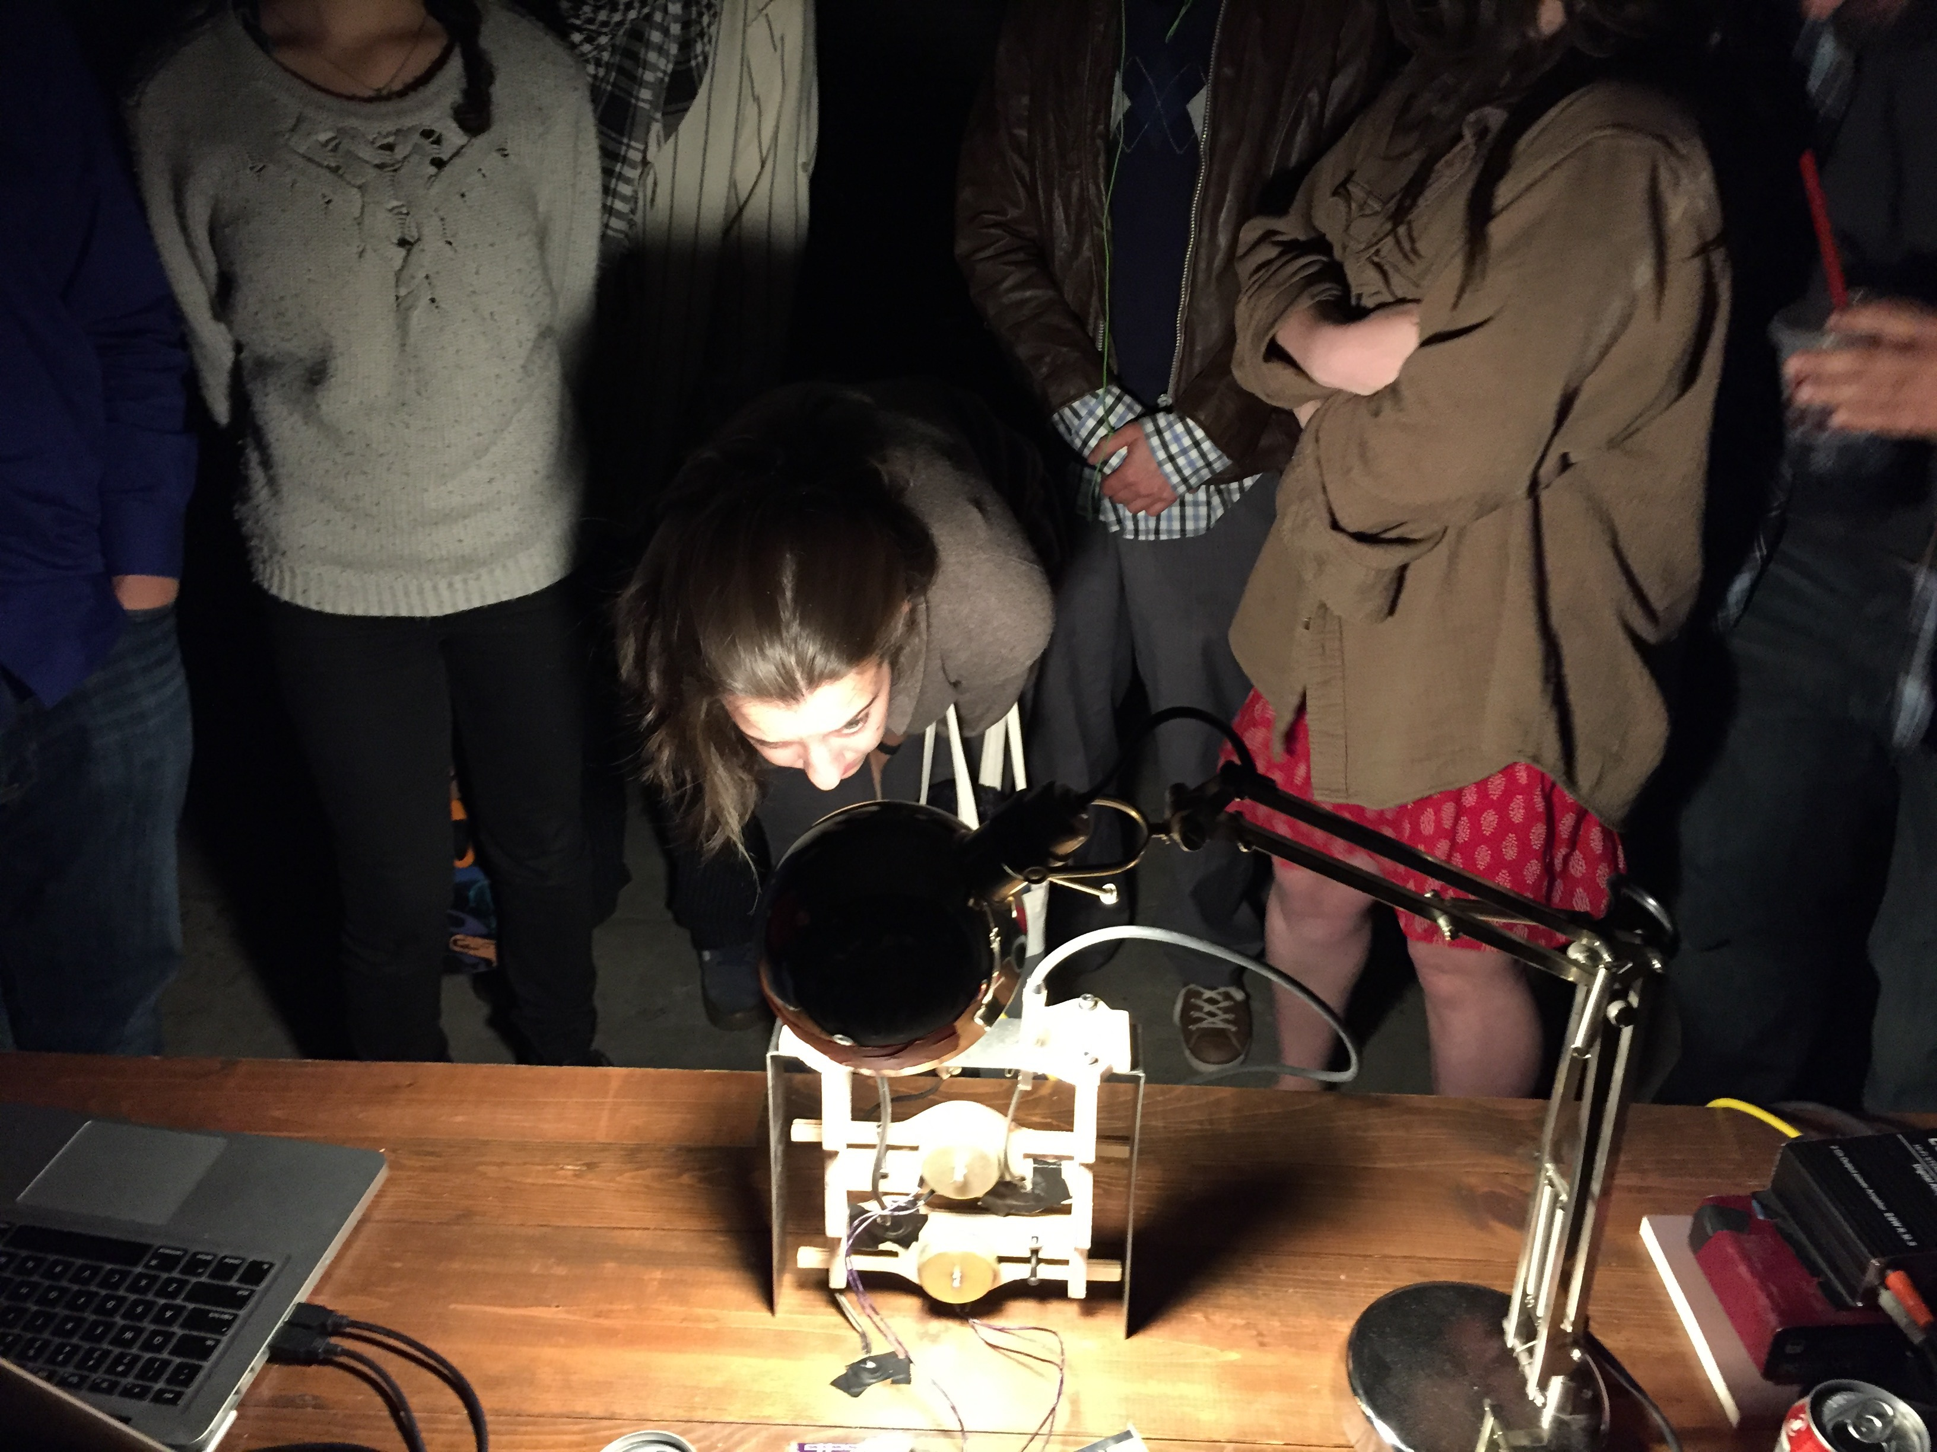

Figure . Animal during performance, with the object in the forefront while the performer takes a photo from the back.

To bring it back to Don Draper, this connection between the two is the pitch. The uncanny experiment, the smashing of the audio cables, the disobedient mechatronic, the equalization of roles; these elements together create an atmosphere that is magic. It’s an attempt at presenting *something* relatable during *Animal’s* performance. During the performance, one could be guiled into believing that a metaphorical soul exists inside the sculpture, but that isn’t the goal. The goal is the creation of an event that recalls moments of humanity and mortality within the audience.

# ../red-mitsubishi-hm-2.jpg Mechatronic Installation // Red Mitsubishi

*“The International Herald Tribune, on the day after the blackout, reported that “the vast but shadowy web of transmission lines, power generating plants and substations known as the grid is the biggest gizmo ever built…. On Thursday [14 August 2003], the grid’s heart fluttered…. complicated beyond full understanding, even by experts – [the grid] lives and occasionally dies by its own mysterious rules.” To say that the grid’s “heart fluttered” or that it “lives and dies by its own rules” is to anthropomorphize. But anthropomorphizing has (…) its virtues. Here it works to gesture toward the inadequacy of understanding the grid simply as a machine or a tool, that is, a series of fixed parts organized from without that serves an external purpose.”*

* Jane Bennett, *Vibrant Matter[30]*

## The Grid’s Heart Fluttered

Jane Bennett, in her book *Vibrant Matter: A Political Ecology of Things,* discusses the North American blackout of 2003 from the stance of a vital materialist. Earlier in the book Bennett describes “*Thing power”,* which “draws attention to an efficacy of objects in excess of the human meanings, design, or purposes they express or serve.” To put it squarely, sometimes anthropomorphizing an object or assemblage of objects can create an understanding that reduces that its complexity. In terms of the blackout, granting an object “*Thing power”* “works to gesture toward the inadequacy of understanding the grid simply as a machine or a tool.” It is a thought experiment that can create broad strokes of understanding for a complex system.

*Red Mitsubishi* isan installation that consists of eighteen solenoids affixed to the walls of a room. They’re laid out in a circuit like configuration, and at the center of each circuit is a ‘node’ that consists of an Arduino and a power supply. The solenoids inside the space are continuously actuating, some are hitting the wall, some aren’t. The sound is constant, repetitive, and slowly-morphing. Because of the vibrations of fixtures and the wall, as well as the sound of the solenoids themselves, it resembles an earthquake caught in limbo.

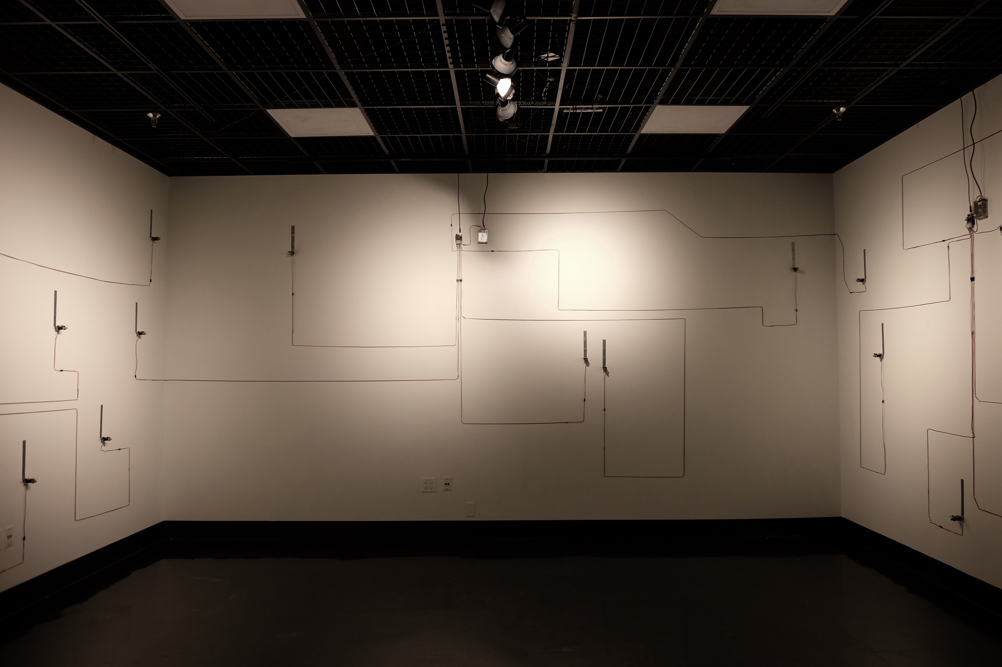

Figure . Red Mitsubishi installed in the WaveCave at CalArts.

The installationis an homage to my car that I totaled the previous winter. It is statement on purpose. After the accident, I had to deal with this object that was figuratively attached to me for the past fifteen years, and the installation deals with the questions that came up during its disposal. The following is from the installation’s wall text.

But what would it have meant if I had kept it? In its last state it could turn over, but the radiator would probably overheat if I drove it for more than a few minutes. What would it have meant to have kept an object that had no purpose? I mean, I'm no mechanic, I don't have space for it anywhere. What, then, would its purpose be?

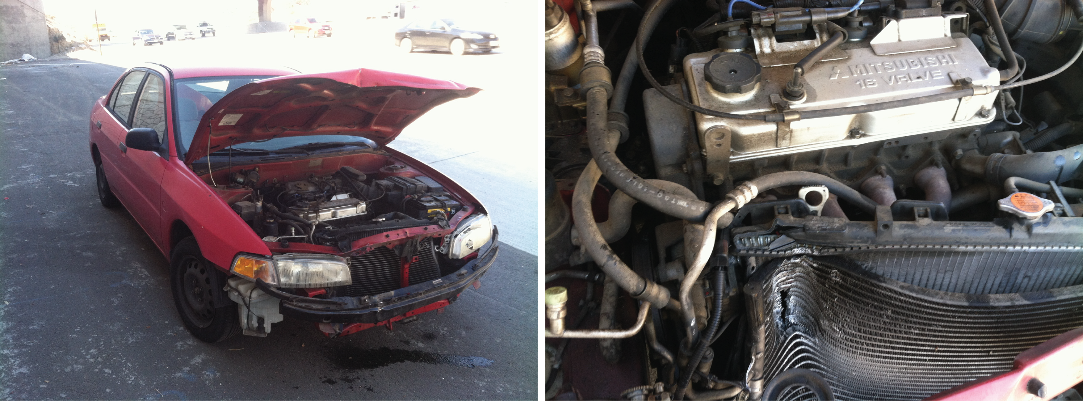

Figure . The original totaled Red Mitsubishi, after the accident on Interstate-5.

The installation plays with the idea of purpose, but a purpose that is instilled with failure. The installation is a metaphorical recreation of the accident; a recreation that plays out over the course of a week.

So these things that are attached to the wall, they never strike the wall, but they’re poised as if they were meant to. They’re being driven so hard that they can’t finish a complete strike. They get ever so close to striking the wall, but they’re being driven so fast that they retract before hitting the surface.

If they happen to strike the wall, it is definitely outside of my intention of them, but they again I am still definitely allowing for that contingency. I mean, it’d be impossible not to. These things aren’t perfect, they break, the caps on them get unscrewed, the zip ties slide back and forth, the programming is ripe with human error, etc.

The solenoids are set to actuate so quickly that they never hit the wall. While the installation prescribes this purpose to the solenoids, what does it mean when they do hit the wall? The installation *did* grant them a purpose, but are the regulated against finding their own? Say a solenoid does ‘malfunction’ and hit the wall, it may be falling outside of the purpose it was prescribed, but at the same time it’s realizing its own purpose of striking the wall.

Bringing back Bennett, these solenoids do “live and die by their own rules.” The installation is filled with many possibilities for failure, with many methods in which the solenoids can fail. Although their failure is allowed, and indeed the defining concept of the installation, the manner in which they fail still remains an emergent property of the work.

Bennett mentions this emergent property when describing the power grid as an assemblage, “Assemblages are not governed by any central head: no one materiality or type of material has sufficient competence to determine consistently the trajectory or impact of the group. The effects generated by an assemblage are, rather, emergent properties.” Indeed, in the installation each individual solenoid is an assemblage of parts, there is no “central head,” the electricity sent by the power supply, the electromagnet, the solenoid housing, the steel fixture that holds the solenoid; these are all points of failure. The particularities of the machine are prone to disorder; the programming is “ripe with human error.” In short, instead of thinking of all the points of failure that are intentionally allowed, it’s helpful to anthropomorphize the solenoid, or even further to think of it as merely a part of the assemblage that is the installation itself.

## Technological Implementation

This installation requires less technology than the other two in this thesis. The spirit of the installation refuses ‘technological glitter.’ Instead, it realizes Odell’s sentiment from chapter 1, ‘novel uses of familiar tech.’

### Design // Construction

Push-pull solenoids were chosen for this installation because their insecure design. Having worked with them extensively on other projects, I’ve come to expect the screw-on caps of the solenoids to loosen after prolonged use. The entire contraption falls apart when the cap becomes loose enough, with springs and other bits falling to the ground. Realizing the delicacy of these solenoids grants them the ‘novel use’ that Odell mentions.

An initial design involved CNC cut wooden fixture that would screw onto the metal, but that was scrapped as it was cost prohibitive and generally impractical. If the wood was secured tightly to the steel, as it was in *Animal,* the fixture would prove too dependable. Instead a crude zip-tie implementation was used to affix the solenoids to the steel brackets. This implementation ended up being preferable to the more secure solution because it allowed for another point of failure. The zip-ties could now slide around due to the solenoids actuations, which would allow the solenoids themselves to move either too close or far to the wall.

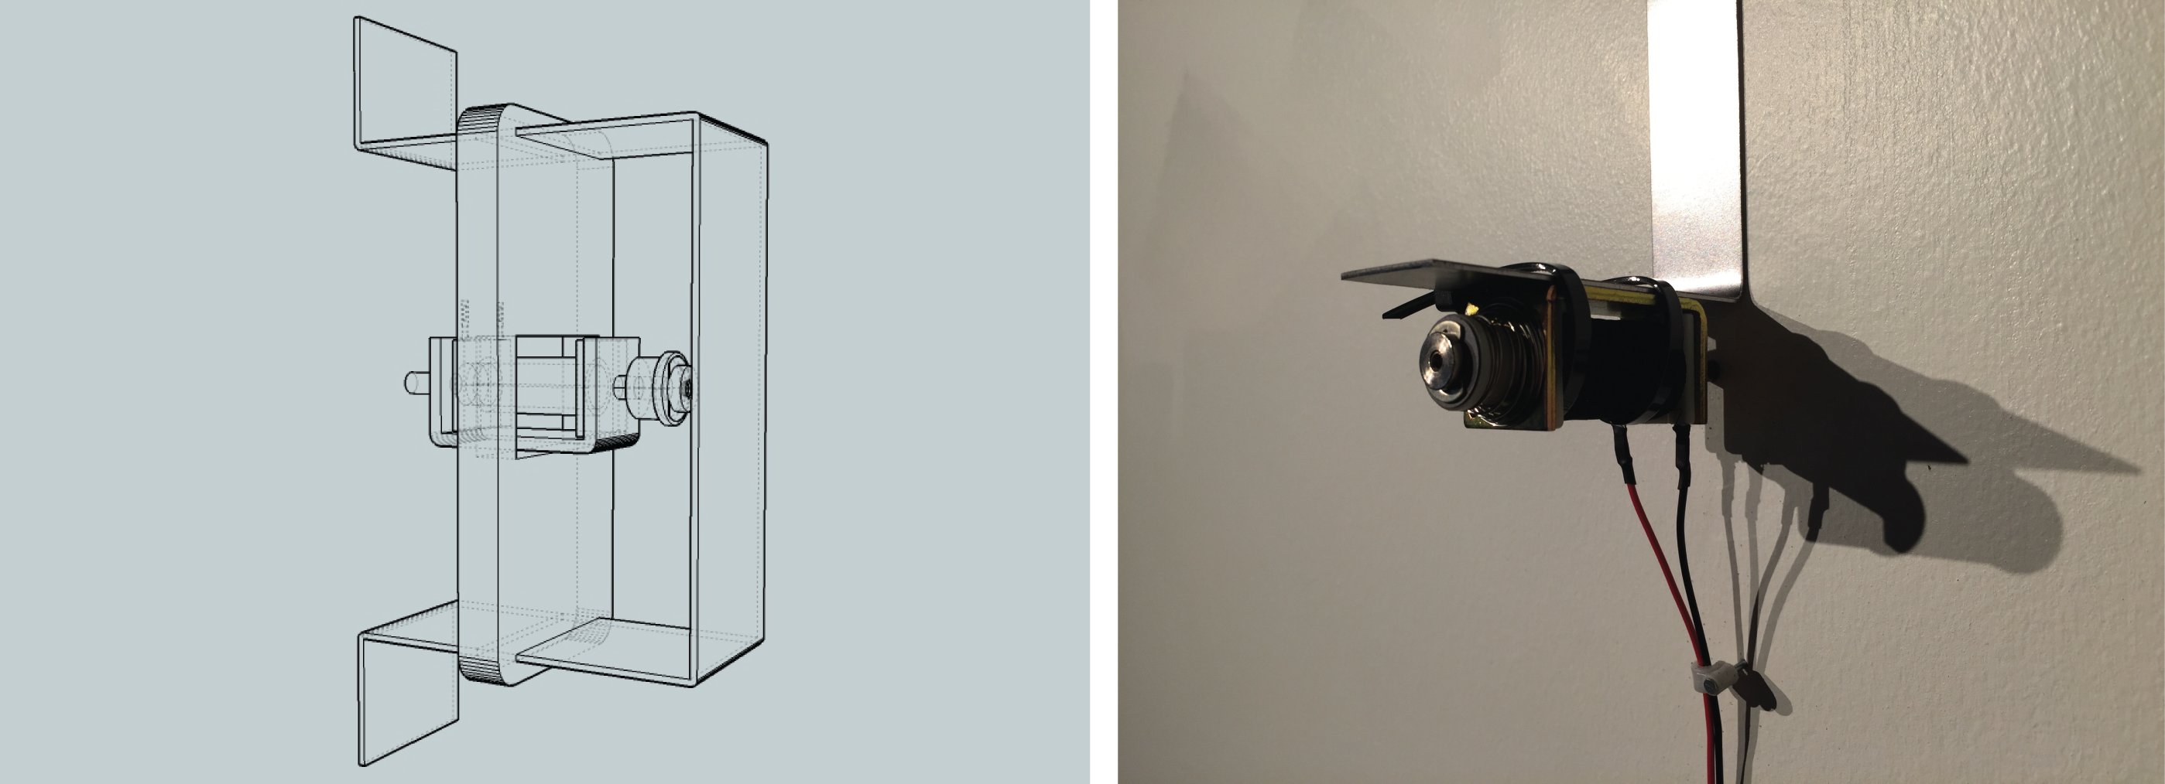

Figure . Draft of the initial fixture design alongside its final implementation.

Individual metal brackets for each solenoid were made from 16 gauge sheets of cold rolled steel. They were cut, punched, and bent in the CalArts super shop. The brackets were then screwed directly into the wall of the space, allowing for the wall to shake itself.

While installing the work, the solenoids were placed around the room with a special care. A solenoid would be held against the wall to find the ‘sweet’ spots (areas that were sonically interesting). This resulted in a few clumps that emphasized the hollow areas in the wall, which would bring out a low end timbre; or dense areas of the wall where a more ‘tinny’ sound would result from a strike. Although the purpose of the installation states that the solenoids should never hit the wall, their placement was still considered in the case of their disobedience.

### Meepo // Arduino

Three Meepo PCBS were used in this installation, each one being a hub that controlled six of the solenoids. All of the solenoid logic is contained within the Arduino itself as opposed to an Arduino receiving serial from ChucK.

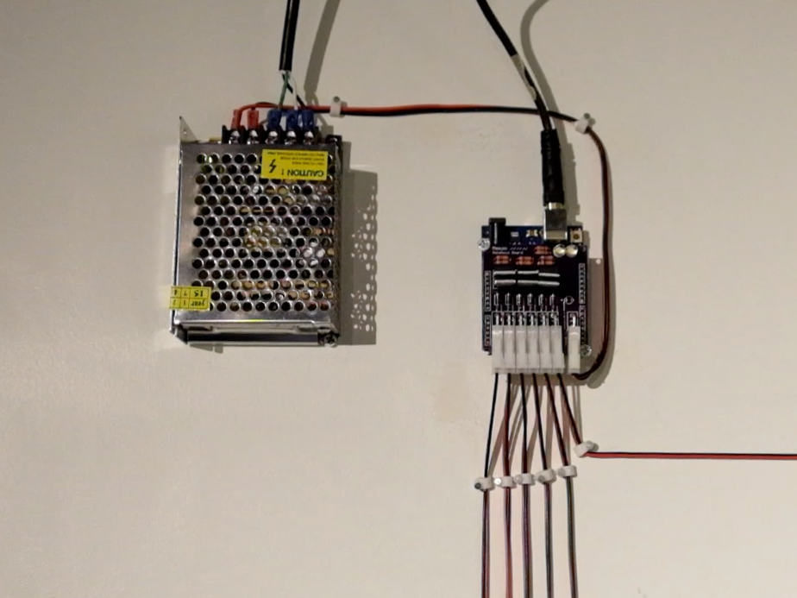

Figure . Power supply and Meepo/Arduino combo, one of the nodes that controls six of the solenoids.

The code in each Arduino places each solenoid into its own concurrent loop, allowing for the eighteen solenoids to actuate independently from each other. The programming slowly alters the velocity and time between actuations; a high velocity with a short actuation time could lead to the solenoid not striking at all, while a lower velocity with a long actuation time would allow a full strike to occur (although the solenoid is initially set the proper distance away from the wall so even a full strike shouldn’t hit it).

The programming is fairly uncomplicated, as much of the complexity of the installation relies on the frailty of the objects themselves. While the random processes found in the programming could lead to a solenoid failing to fire at all, the more common causes failure come from the delicate nature of the materials.

## ../narrative.png../complexity.png../noise.pngDiscussion

The aesthetic characteristics of this work differ slightly from the other two works in this research, as *Red Mitsubishi* is an installation rather than a performance. The physical narrative in the other two works relies on human action and occurs over the course of ten to twenty minutes, but any narrative found within *Red Mitsubishi* is reliant on the physicality of the material itself and occurs over the span of the week. These attributes as a result produced a much different pitch than the other works, it being one that aims to highlight the connection between the audience and the mechanical objects we deal with daily.

### Characteristics

The sonic characteristic of noise and systemic characteristic of complexity work well together in this installation. A wide variety of noises was created due the system’s complexity, with the noise of the installation describing the emergent behavior of the system. As the installation fell into disrepair, the sonic environment followed.

For instance, when functioning to its prescribed purpose, a solenoid would never strike the wall and would instead merely vibrate the fixture. Since the fixture was screwed into the wall, the wall would vibrate as a result. The resulting sound became the combination of the solenoid actuating and the wall, which was surprisingly audible.

When a solenoid would ‘accidentally’ strike the wall (either due to the zip-tie implementation or the screw-cap loosening), the corresponding bang was extremely audible. Many of the solenoids would slide too close to the wall, denying the them any movement. Some of the solenoids fell apart entirely after the screw-cap loosened, leaving their parts strewn about the floor. One solenoid remained intact but burnt out from the constant surge of electricity, leaving behind a whole but useless corpse.

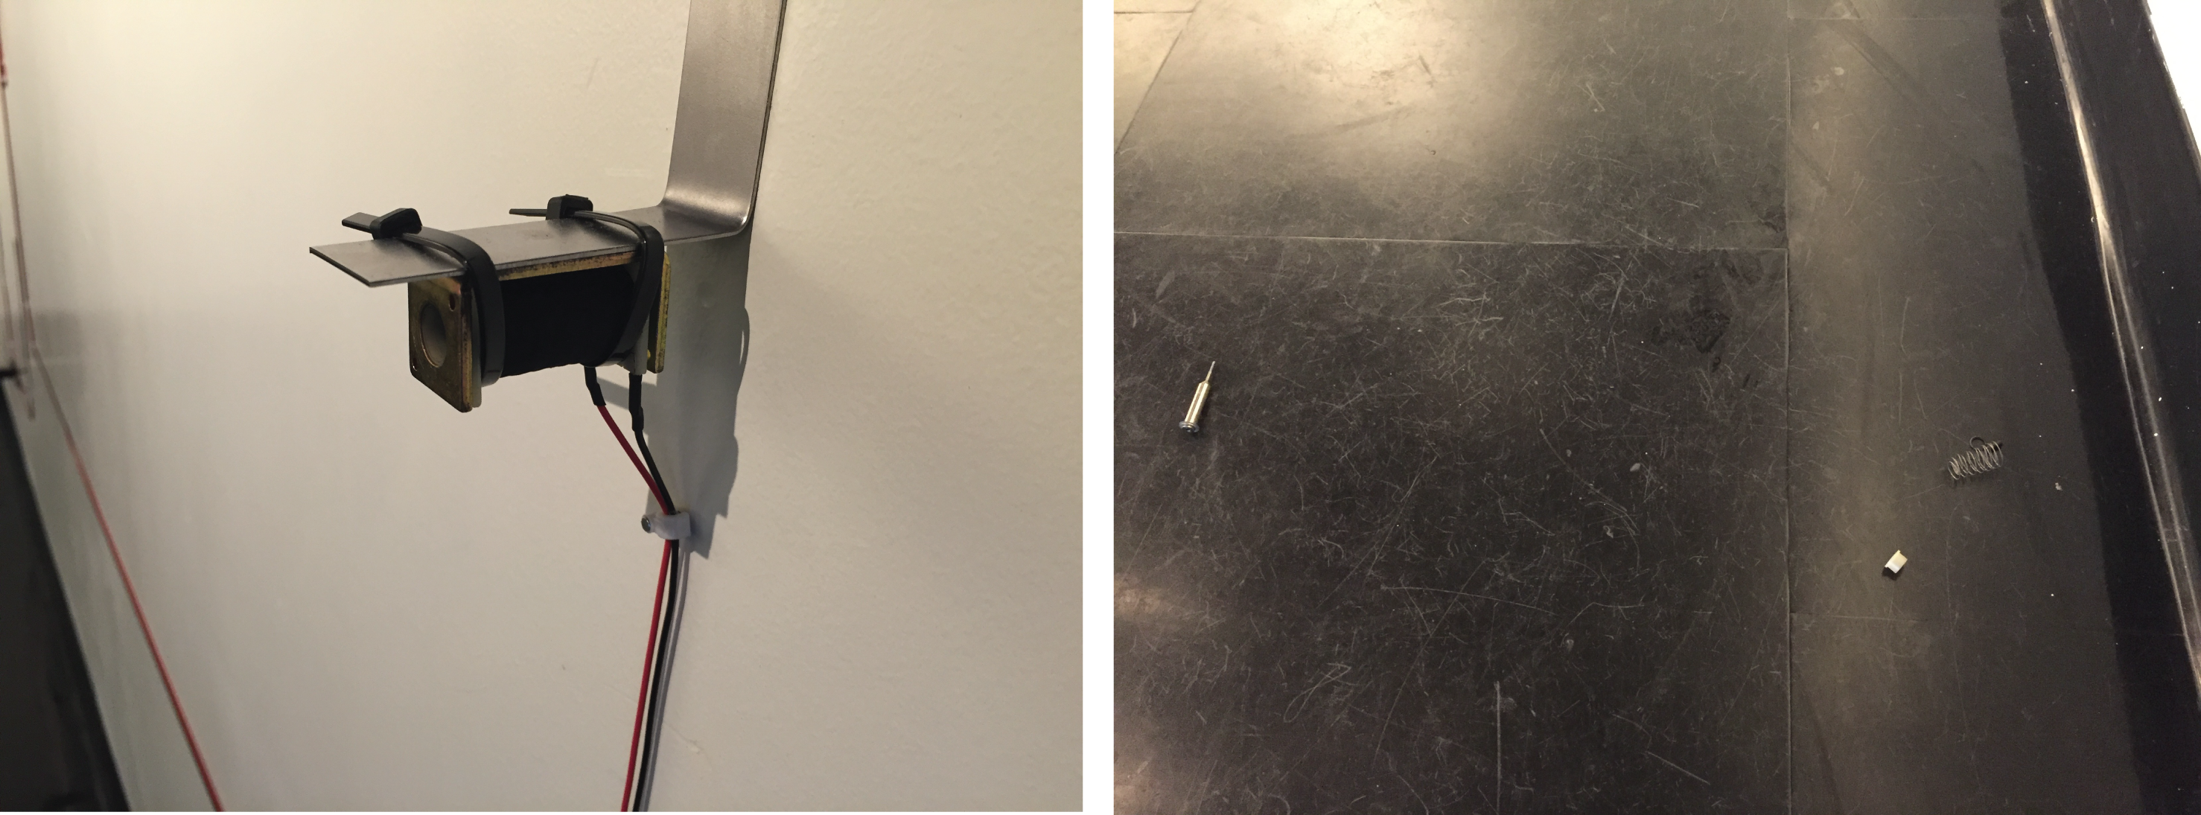

Figure . A retired solenoid and the pieces that comprised its mechanism lying beneath it.

While there is a narrative in this work, it is quite different from *Animal* or *Beast.* The narrative in this installation is progressed by the physical limitations of the solenoids, rather than human action. The narrative, much like the sonic environment, was subject to the system set in place. This narrative developed because of the system’s complications. Over the course of the week, more and more of the solenoids would fail due to their prolonged over-actuation. An onlooker could only notice the arc of the grid’s destruction from subsequent visits, whereas someone visiting the installation once could only notice its disheveled middle state.

There is a second narrative, one which does indeed involve human interaction. During the course of the week I would enter installation and fix some of the mechanics, and although I didn’t realize it at the time, I was creating a new narrative. I thought I was ‘outside’ of the installation when I was fixing it, and that my maintenance of the solenoids and their fixtures had no conceptual underpinnings. But really I was changing *Red Mitsubishi’s* metaphorical oil. A new narrative was created that involved a creator who was compelled to keep her piece alive. I felt a need to keep the system operational. From the moment the installation went up it was on life support, with its ‘heart constantly fluttering’; and I couldn’t let it go.

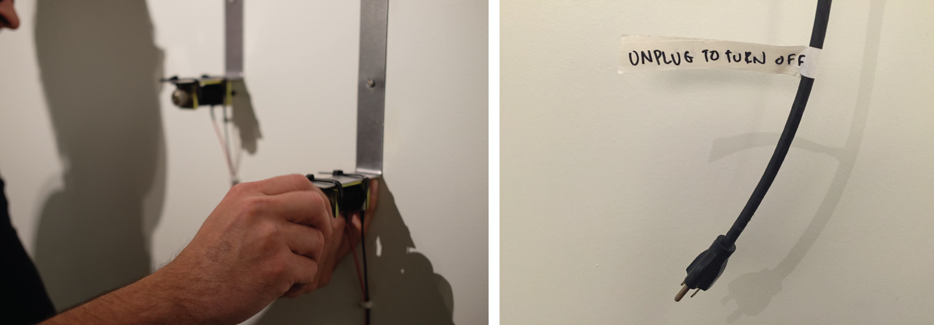

Figure . Me repairing one of the broken solenoids on the left (and meddling with the conceptual intent of the installation), and a power cable that allowed one to ‘pull the plug’ on the installation.

### Pitch

Yasunao Tone’s *Solo for Wounded CD* alsodeals with the idea of machines failing. Tone started experimenting with prepared compact discs in 1984, as he would block “the laser beam with a bit of scotch tape, which altered the CD-information.” “If you scratch analog recordings you can predict what kind of sound comes out, but with the digital you have no way of predicting.”[31] Tone’s idea of unpredictability is tied to complexity in this research; his justification being that machines should be prone to the same mistakes that humans are.

Machines are designed not to make mistakes. In our behavior we often make mistakes, so why not machines also? Enabling machines to make mistakes is more interesting than not to make mistakes.

Tone isn’t directly anthropomorphizing his compact discs, but he is altering their purpose. The CD’s failure becomes its new function. The solenoids in *Red Mitsubishi* weren’t modified, but they’re functioning on the same conceptual slant as Tone’s CDs. They’re enabling machines to be relatable to the mistakes ‘we often make in our behavior.’ The product of their failure being unpredictable and complex; the same unpredictability that arises with any drastic change in our lives.

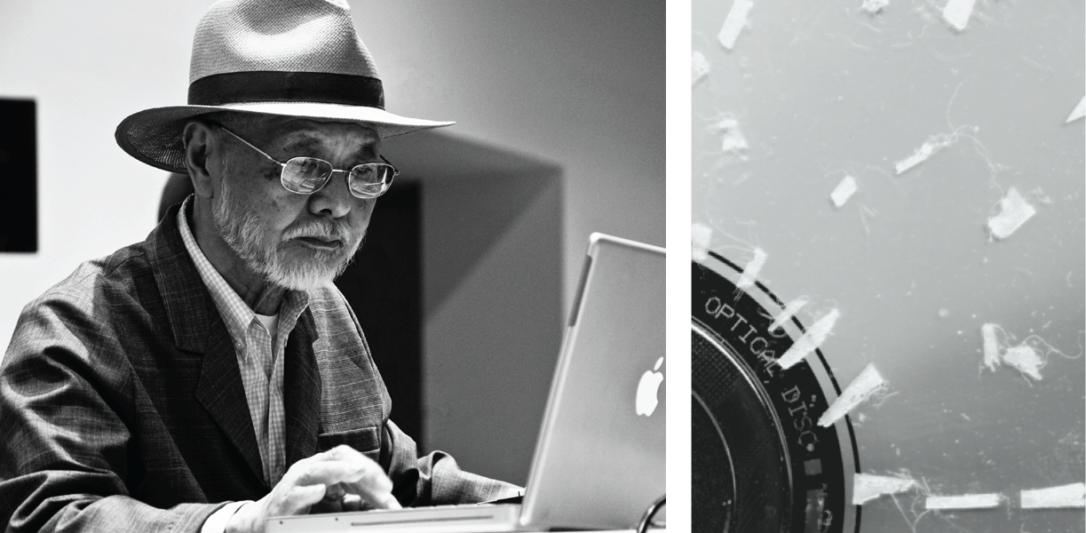

Figure . Yasanao Tone and his "Wounded CD", a compact disc prepared with pieces of tape.

When my car was totaled in the winter of 2015, I felt like I had lost an appendage. I had relied on it daily for the past fifteen years, to have it suddenly die affected me in a drastic and immediate way. Of course in the end it’s only a car, something that’s entirely replaceable; I was still able to ride the bus or bum rides from my friends. But there is still conceptual weight in dealing with the loss of an inanimate object. Could the destruction of my car, coupled with the intent I prescribed to *Red Mitsubishi*, evoke moments of human mortality?

Jonathon Schipper’s *Slow Motion Car Crash* is a long duration installation that slowly smashes a car into a wall over the course of a month. With the aid of a hydraulic cylinder, the car is set to move “at a speed of 7mm per hour in a choreographed collision.”[32] The artist states that the car’s smashing into the wall represents a “dramatic inevitability that reflects our own mortality,”

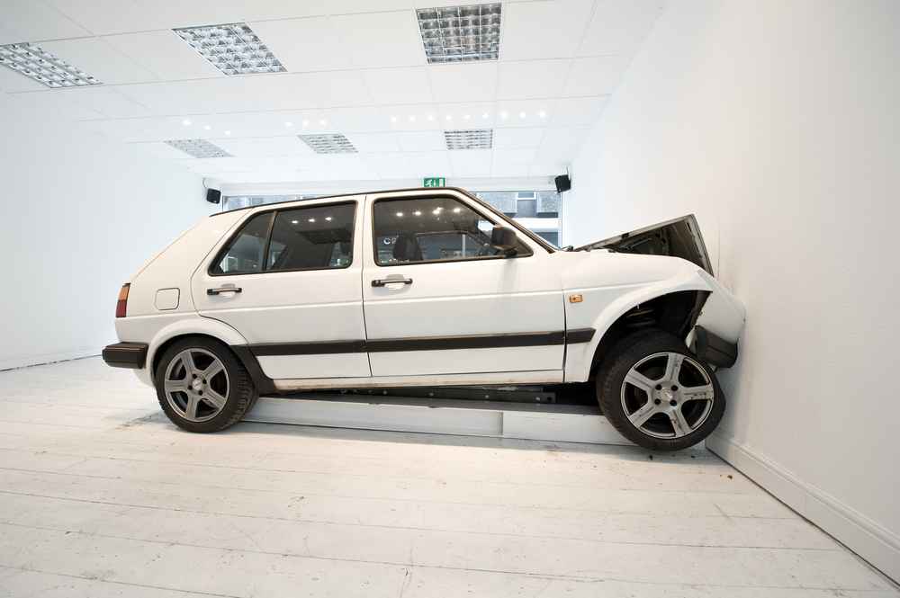

Figure . Midway through Jonathon Schipper’s *Slow Motion Car Crash.*

Because of the rate of the car’s movement, it’s unlikely that anyone could witness any real destruction during a single visit installation. Only snapshots of the car’s destruction can be glimpsed. And Comparably, we seldom recognize the mortality of ourselves or others unless over the measure of a long period.

*Red Mitsubishi* offered a similar glimpse into its inevitable demise (regardless of the covert repairs made by its creator). And much like any dying being (and most mechanical objects), its clamor increased as it approached death; the solenoids crying out a sonic objection to their sickly state. Left to their own devices (quite literally), they eventually fell silent.

As Bennett mentions, the installation drew attention to the “efficacy of objects in excess of the human meanings, design, or purposes they express or serve.” *Red Mitsubishi* rattled away at an untenable rate, and with it emerged a variety of caterwauls and death calls. And this was its pitch; the system’s flailing and shrieks. ‘The grid’s heart fluttered’ and allowed moments of mortality to seen through the mechatronic’s limited existence.

# ../beast.jpg Mechatronic Performance // Beast

*"Since the body could not be removed, no one had to worry about how to put it back in. The problem can be precisely dated to the moment when early tape music pioneers first put a tape deck onstage and announced that their performance would consist of hitting the “play” button, and a confused audience asked, “Was that really a performance?*

*Since then, the problem has been reformulated again and again in various ways yet never solved. For the entire problem is just one window into the tension residing at the very core of modern life – that between the human body and the machine. (...) It cannot be solved in the sense of a solution that can make a problem disappear. It can only be experienced in various ways. (...)*

*Artists who use machines must do so critically; not celebrating technology but questioning and probing it, examining its problematic nature, illuminating or clarifying tensions between technology and the body, and thus offering the kinds of insights only art can provide concerning the nature of life at the dawn of the third millennium.*"

* Bob Ostertag, *Human Bodies, Computer Music*[33]

## A Fertile Ground

In computer music, a performance might consist of a performer “sitting on stage and carefully moving a knob a fraction of an inch,” or “sitting on stage and moving a cursor by dragging one’s finger across a track pad in millimeter increments.”[34]

Thus we enter the age old critique of most electronic music performances. How can a modern electronic musician can travel the vast technological distance between her body and the computer? Ostertag concludes that the only current path is to clarify “the tensions between technology and the body.”[35] He sees no immediate solution, but rather asks us to investigate the difficulties inherent between humans and machines. *Beast* is a mechatronic performance that, much like *Animal,* investigates this tension.

*Beast* creates a malleable narrative between a performer and a responsive mechatronic sculpture. This piece focuses intently on the relationship between the performer and the object. While the object does have a kinship to the Odradek, that kinship is the starting point of *Beast,* as opposed to a reference. This performance is beyond the point of *Frankenstein-*like experimentation, which was the focus of *Animal*.

The piece with a sculpture in the center of the stage, and three rotary solenoids surrounding the sculpture and covered with small brass chimes. Much like *Animal,* the object stands as if had always been there, and alongside it is an open computer and a few quarter-inch audio cables hanging off a nearby lamp.

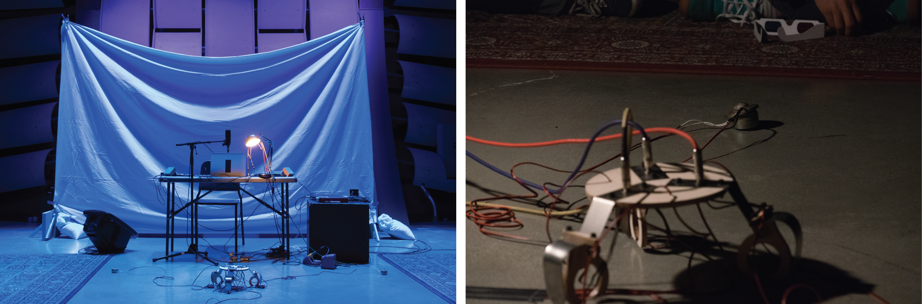

Figure . The setup of *Beast* on the left, a chime resting on a solenoid on the right.

The three solenoids begin quietly actuating in metered rhythms, gently pinging the chimes. The performer stares intently at the layout, but unlike *Animal,* the performer doesn’t approach *Beast* as if she’s contemplating its purpose. Instead, the performer is merely occupying the space with the object, as if they were acquaintances. This isn’t an experiment (as was *Animal*), it’s a rendezvous.

On the sculpture itself are three input jacks for the three audio cables, each associated to a solenoid. The performer begins plugging the audio cables into the sculpture (this marks the solenoids entrance into a system). The performer then brutishly kicks the brass chime off of the solenoids, picks up the solenoids, and stalls them into the small wooden fixtures attached to the object.

Loud rhythmic pulses follow, amplified by the contact microphones that are affixed to the steel support of the structure. The rhythms of the solenoids start drifting form each other until they start to sputter nonsensically. The performer nudges the object with its foot, as if her involvement could correct the object’s course. Instead, the object goes silent, refusing the intentions of the performer. The performer gives the object a long stare, mutters something profane, and violently kicks the object; it reacts accordingly.

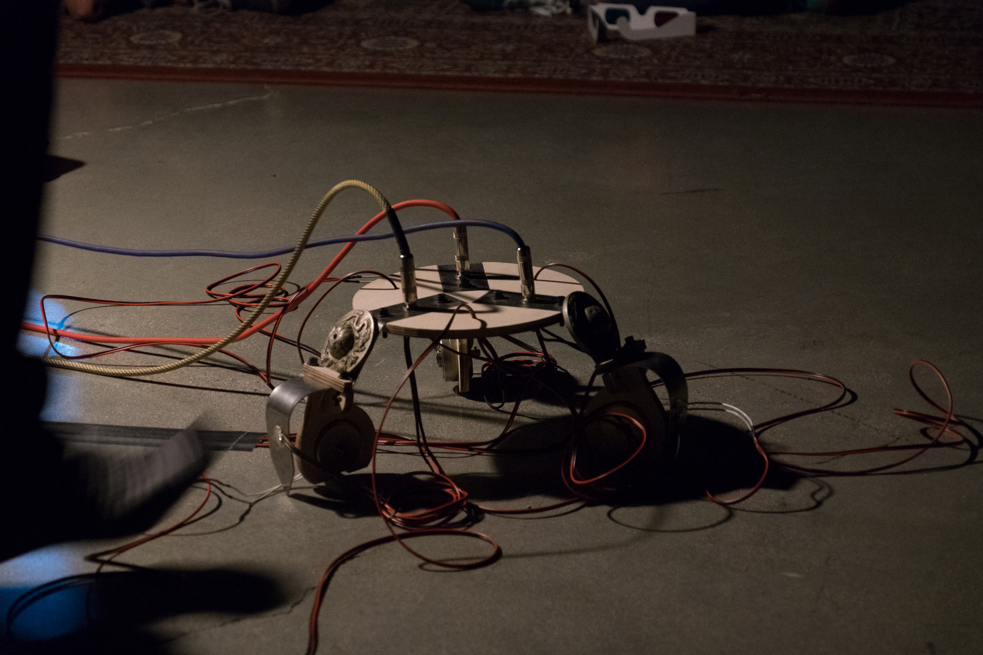

Figure . *Beast* moments from the ‘kick’, at CalArts Wild Beast performance space.

A chaotic soundscape ensues. The solenoids are firing forcefully, filling the room with noise. The mechatronics are vibrating so harshly that a few of them begin to fall out of their fixtures. The loose solenoids begin sliding around the ground as they fire haphazardly; the contact microphones now amplifying the vibrations of the floor around the object. The performer inspects the wreckage and starts spreading the solenoids away from the object.

The performer has given up on the sculpture’s purpose; she’s frustrated at the object’s inability to simply hold the solenoids. She begins placing the loose solenoids away from the object, their vibrations isolated from the contact mics on the object. Any solenoids still enclosed in their fixtures are brutishly exited and spread about the stage. The performer then unplugs the audio cables and places them back on the lamp. Much like *Animal,* the solenoids slowly start to falter as they’ve lost their connection to the system. One by one, the solenoids begin falling silent. In a moment of foreshadowing, the performer then begins moving the contact microphones from the mechatronic object to the solenoids themselves (the contact microphones still unattached from the audio cables).

After all the solenoids have gone quiet, the performer takes an audio cable from the nearby lamp and begins striking a metered rhythm onto the tip of the audio cable. A corresponding solenoid starts actuating, mirroring the strikes of the performer. Soon the solenoid takes on a rhythm of its own, similar to the one that the performer tapped into the system. After waking all three of the solenoids, the rhythms start accelerating and simplifying. The performer places the chimes back on the solenoids, situating the stage much as it began. The solenoids eventually go silent, while the performer watches them in expectation. After about half a minute the solenoids release one last jolt which frightens the performer, and the piece ends.

*Beast* very much involves the body of the performer into the piece, and is accomplished with the absence of a controller or an interface. Instead, merely by fulfilling a prescribed narrative, the performer’s body is constantly involved in the piece. This sidesteps the issue that Ostertag explicates; the issue being “how to get one’s body into [an] art that is as technologically mediated as electronic music, with so much technology between your physical body and the final outcome.”[36]

This actions of the performer make visible the tension between humans and machines visible. Ostertag describes this tension while describing his own work.

My first record, *Getting A Head*, involved a highly unstable “instrument” made by running the same spool of recording tape through three tape decks lined up one after another. Performances were duets of myself and an instrumentalist whose playing was recorded on the tape running through the three decks during the performance.[37]

When reflecting on this piece, Ostertag admits that “what stood out was not the technologically mediated relationships between musicians but the confrontational relation of musicians and machines.”[38] Ostertag, in his attempt to highlight the relationship between him and the ‘technologically mediated’ instrumentalist, instead highlighted the problematic nature of technological mediation. This tension existed the moment that Ostertag decided to work with machines, and indeed exists in all electronic performance.

*Beast* exploits this tension by focusing on the relationship between the performer and the object. The narrative of the piece relies on the performer and object frustrating each other, neither of which end satisfied with each other. *Beast* frustrates the performer enough that she is left kicking the object, while at the end of *Beast* the object leaves the performer with one final scare. Much like *Animal,* this tension works to equalize the role between the performer and the object. Instead of the performer acting as a manipulator of the object, she is a cooperator. What results are the moments of affection and aggression that together create a flawed relationship, the tension of which is left unresolved.

## Technological Implementation

This piece features practically the same technology found in *Animal* (CNC cutting, PCB manufacturing, Arduino and ChucK programming). What separates it from *Animal* is the sophistication of the programming; which ultimately leads to *Beast* containing more personality than *Animal*. The design is also much less anthropomorphic than *Animal,* as *Beast* isn’t fielding any existential questions; the questions that *Beast* creates focus on the relationship between the two cooperators on stage.

### ChucK // Markov Chains

*Animal* has a strong narrative element comprised of human actions and a noise-ridden sonic landscape. What *Animal* was lacking was a sufficient amount of systemic complexity. While a relation was created from performer to the object, a lack of complexity in the programming of *Animal* corresponded to a lack of complexity in the interactions between the two.

This systemic complexity is present in *Beast.* There is a moment where the object figuratively goes to sleep, leaving it up to the performer to wake it in order to progress the piece. In the code, there is a function named wake(); which leaves the object still, awaiting input from the performer. The performer takes one of the unplugged quarter-inch audio cables with one hand, and begins tapping it against the other (there are three audio cables, corresponding to three solenoids). This tapping creates short impulses that are fed into the system, and a solenoid begins actuating alongside the performer’s tapping. After enough impulses have been fed into the solenoid, the solenoid starts actuating on its own to a rhythm much like the performer’s rhythm; the solenoid’s own rhythms then start augmenting and changing on their own.

During the wake() section, the timings of the performer’s rhythmic impulses were learned by the system, and a tempo and rhythmic pattern was extrapolated from that information. Using this information, a Markov chain and was created by quantizing the rhythmic input, and then a transition matrix was created out of that Markov chain.

A Markov chain is a memoryless and random process that transitions to a new state by analyzing a previous state. By analyzing the frequency in which one type of input follows another, a table of probabilities is formed which can create a new Markov chain. For example, in Figure 25, a sequence of inputs is given that would create the first row of a transition matrix which describes the expected output that follows the ‘A’ type input.

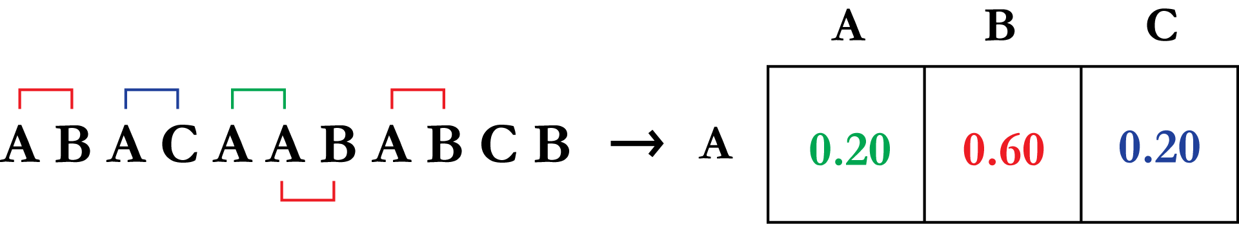

Figure . The first row of a transition matrix being created out of a sequence of inputs.

By analyzing every occurrence of ‘A’ in the input chain, it is shown that the output that follows ‘A’ has a 20% chance of being ‘A’ or a ‘C’, and a 60% chance of being ‘B’. Calculating the other two rows (for ‘B’ and ‘C’) completes the transition matrix.[39]

With a completed transition matrix, a new Markov chain can be created that shares characteristics with its input chain. In *Beast,* the Markov rhythms degrade until they morph into a simple rhythm. This is done by creating a new transition matrix from each subsequent output chain. With enough iterations, a Markov chain will eventually degrade into simple pattern of repeated rhythms. (See Figure 20)

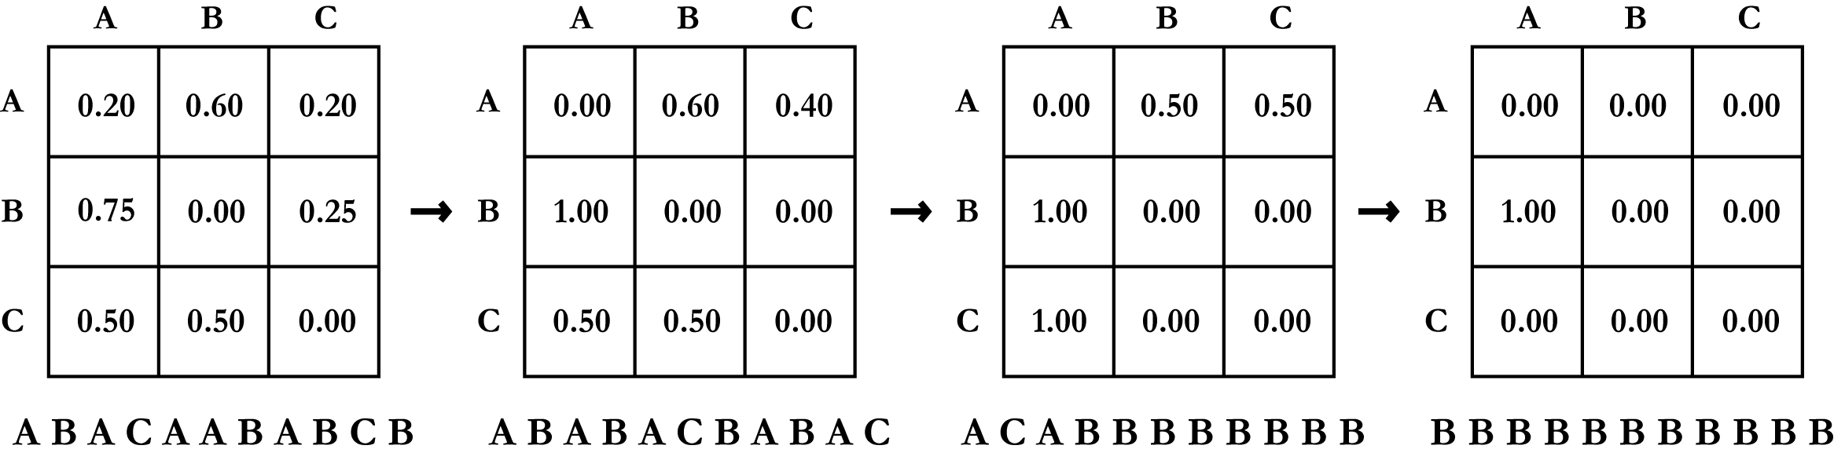

Figure . Degradation of a Markov chain, until a chain of only ‘B’s exists.

In the context of *Beast,* the manner in which the rhythms change and degrade give the system autonomy. After each solenoid is reintroduced into the system, the solenoids run through their own series of Markov evaluations concurrently and independently of each other. Since the physical input from the performer (the tapped rhythms) isn’t quantized; the length, variation of rhythms, and tempo of each solenoid is vastly different from one another. This facet of the piece helps form a complex system that encourages emergent behavior, which in turn lends the object a personality. The performer isn’t responding to a basic set of primitive functions, but to a developing and unpredictable system. The emergent behavior of *Beast* also ensures that each performance is different from the previous; it will be discussed later on the piece evolved over subsequent performances due to its complexity.

### Design // Space

The design of *Beast* put many considerations into space around it. To enable the performer to fully put her body into the piece; the legs, fixtures, input jacks, and solenoids were spaced equally around a circle. This design requires the performer to interact with all the different sides of the object, moving around it mid performance. This is a departure from *Animal*, which limited the space the performer had to work with.

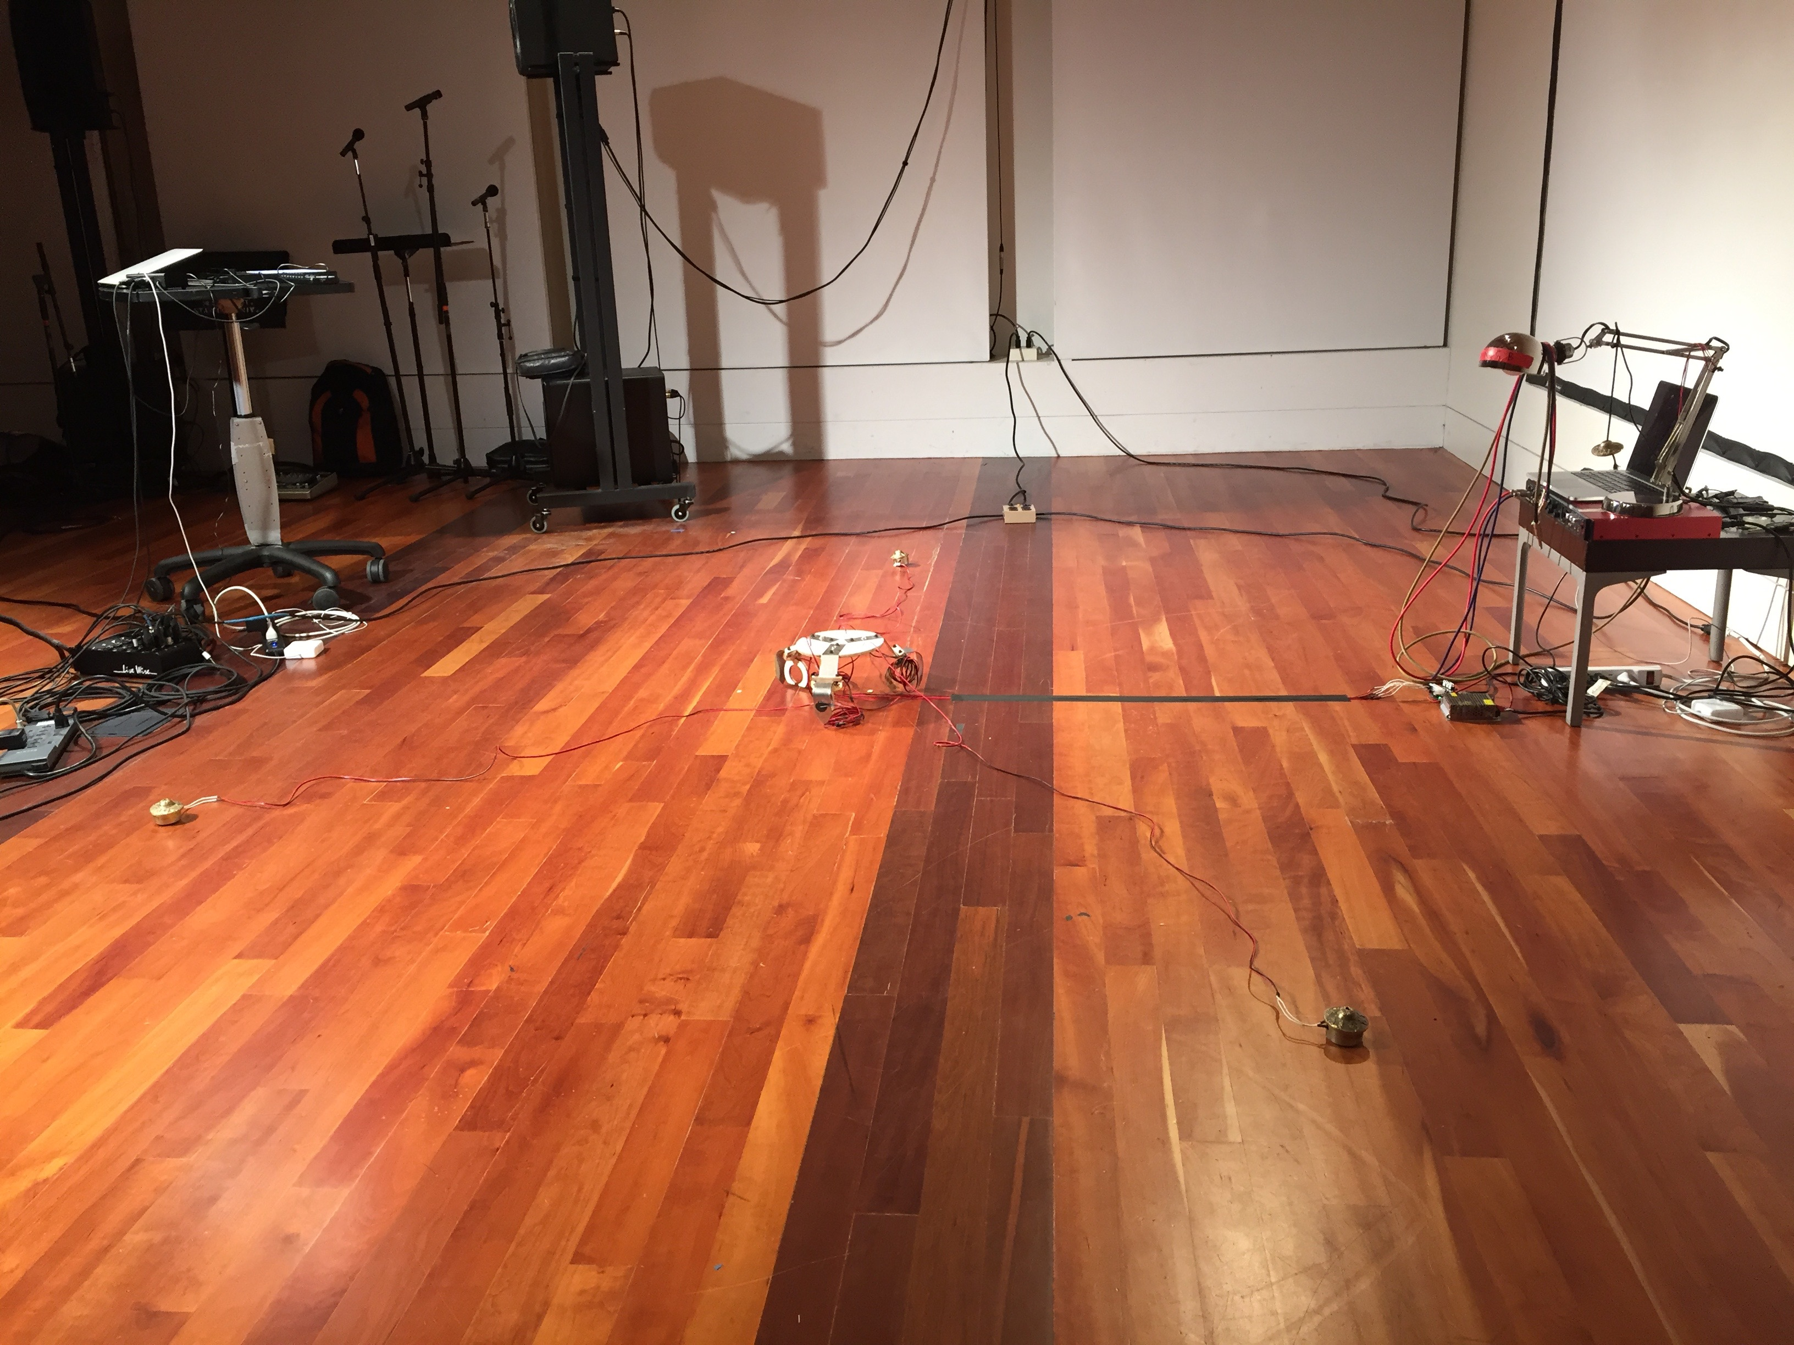

Figure . *Beast* setup at the CCRMA stage at Stanford, with the space ready for the performer to inhabit.

## Discussion

*Beast* evolved both during performance and throughout the course of its subsequent performances. The aesthetic attributes that led to its evolution will be discussed here, as well as a discussion about the complex relationship that exists during the performance of *Beast*.

### ../noise.png../complexity.png../narrative.pngCharacteristics

Complexity became the primary aesthetic characteristic of *Beast.* The systemic complexity of the piece allowed for a constantly changing physical narrative which evolved over the course of several performances. Notably, this complexity allowed for the relationship between *Beast* and the performer to evolve as well.

During the first performance of *Beast* (at Wild Beast concert hall at CalArts), there wasn’t a strong expectation of how *Beast* would behave. It was a bit nerve-wracking, the true nature of the piecewasn’t known. To be clear, this wasn’t an issue of the code not cooperating; I was assured that the program would run until the end of the piece. It was more like a first date; we were learning each other through of series of interactions. This performance was the most improvisatory; we were in the honeymoon phase.

The second performance of *Beast* was for the CEMEC (California Electronic Music Exchange Concert) series at CalArts in the Roy O. Disney Concert Hall. This performance was extremely uncooperative, and the piece changed entirely as a result. The piezo contact mics were firmly attached, but a possibility was definitely left for the leads to break off during performance. This happened twice during this performance, but as a contingency, a soldering iron was placed onstage. Amidst the chaos of the performance, the solenoids firing and bouncing across the space, me reacting to the piece to continue its progression, I’m soldering the leads back onto the contact mics. I think of this performance as the first fight in our relationship.

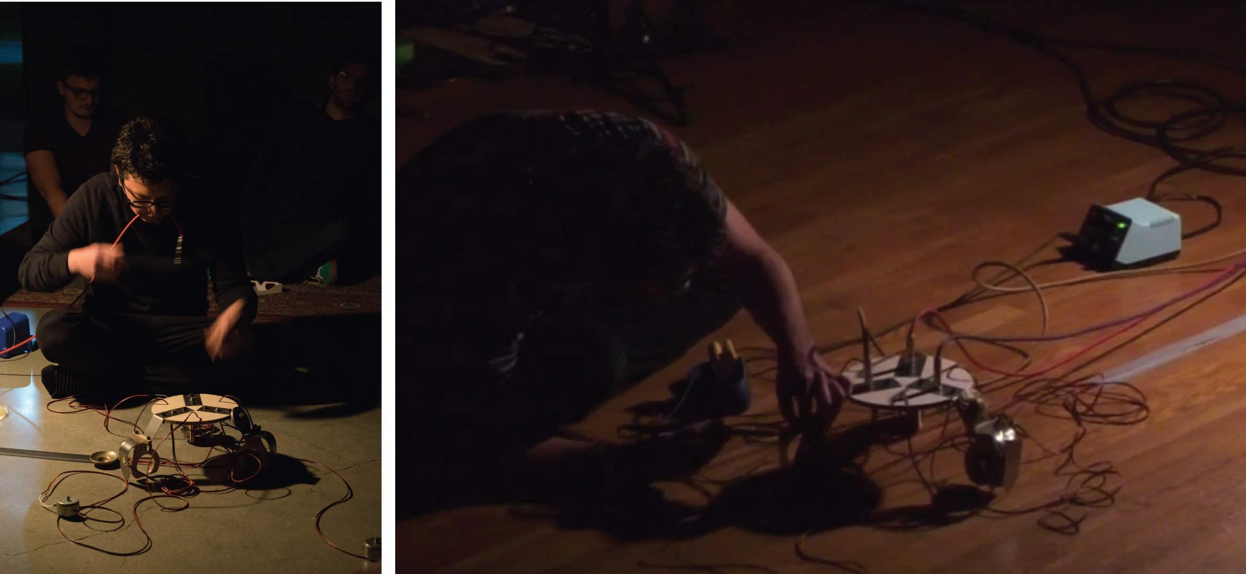

Figure . First performance of *Beast* on the left, second performance on the right (the performer soldering on stage).

The third performance of *Beast* was at the CEMEC concert held at Stanford University on the CCRMA stage. The piezo contact microphones were dipped in plastic beforehand to ensure that the piece didn’t hinge on the mics breaking. This security enabled me to discard the soldering iron on stage (I had prepared a few modular backup contact microphones as well). As a result, the relationship between me and the object became complacent; I could rely more on the piece progressing somewhat normally. The complexity of the piece was diminished, and the relationship between me and it began to grow stale; for a bit, I thought this was the end of our relationship’s development.

The last few performances were unusual for *Beast,* as toward the end of the piece, the solenoids start vibrating at a speed so fast that a tone emerged. At first I thought it was a chance occurrence; merely something that emerged from the unpredictable evolution of the Markov chains. But then during the next performance the tones reappeared. Over the course of several performances*,* I had developed a rhythmic tendency for how I perform the wake() function (the tapping of the audio cables). Throughout the course of these performances I had stumbled upon a rhythmic pattern and tempo which resulted in tones that were vaguely harmonious; notably, this behavior emerged from what was once considered arbitrary input. In the process of me teaching *Beast* my rhythms, I instead ended up learning the rhythms that allowed *Beast* to sing*.* Our relationship was growing stale, but we still learned something new about each other.

### Pitch

This evolution of *Beast* explores this tension that Ostertag discusses in *Human Bodies, Computer Music.* In fact, tension becomes the core characteristic of the work. There is a push and pull between the mechatronic sculpture and the performer as they fulfill their ritual.

Nelmarie du Preez’s *to rely* has many similarities. *to rely* is a recorded performance of du Preez holding a bow and arrow and standing in front of mechatronic sculpture. The video begins with de Preez nocking an arrow to a bow string, which is then pulled taut by a combination of the sculpture holding the arrow and du Preez’s pulling of the bow. This piece is an homage to Marina Abramović’s *Bow and Arrow* in which she pulled on a bow while her partner, Ulay, held an arrow in the bow’s nock.

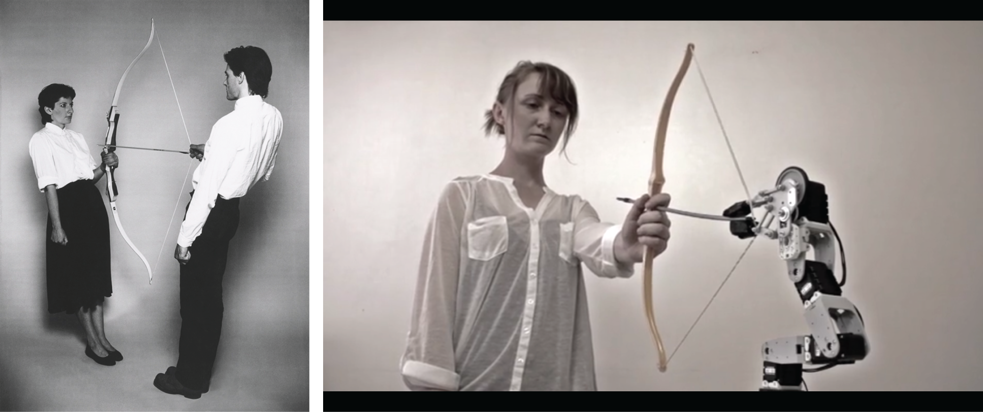

Figure 27. Marina Abramović and Ulay's *Bow and Arrow* on the left, and Nelmarie du Preez's *to rely* on the right (part of Preez's *Loops of Relation* series)

Du Preez is concerned with the tension between the machine and the body (both literally and metaphorically), and is extending Abramović’s exploration of trust into the realm of mechatronics.

In general, my work is concerned with the position of the self in relation to the other, and in my case the other becomes a robot or a computer. Within this relation I want to consider how a human-computer relation can extend our understanding of trust not only in terms of our growing trust in technology but also in each other.[40]

The trust found in *Beast* is just one aspect of its human-computer relation. After the first performance of *Beast,* a friend who was in attendance approached me and discussed the ‘masochistic’ nature of the performance. At first I reacted somewhat defensively, as the term ‘masochistic’ has powerful connotations that I initially wasn’t comfortable with. But soon after I couldn’t help but notice the aspects of the relationship I was uncovering in the piece.

Masochism was definitely a part of the narrative that was unfolding, as was sentimentality and tenderness. These seemingly contrasting characteristics of the work create a contradictory narrative. If the piece were to *stand* for something, its position would be unclear. Is a piece of art required to stand for something in the first place? Is there merit to presenting a contradictory narrative that allows a variety of interpretations? With these questions in mind, it might be worth inspecting the design of the object. Viewed from above, the topography of the sculpture can be seen to resemble the peace symbol. But if you rotate the design a few degrees, you end up something that resembles the colloquial ‘nuclear’ symbol.



Figure . *Beast* and the international symbol for nuclear disarmament (peace symbol), along with the symbol for ionizing radiation (nuclear symbol).

While this wasn’t the original intention of the design, there is a duality present that reminds me of a relevant conversation from the Stanley Kubrick film, *Full Metal Jacket.* In this scene, Private Joker is being addressed by a superior officer.

COLONEL: Marine, what is that button on your body armor?

JOKER: A peace symbol, sir.

COLONEL: Where'd you get it?

JOKER: I don't remember, sir.

COLONEL: What is that you've got written on your helmet?

JOKER: "Born to Kill," sir.

COLONEL: You write "Born to Kill" on your helmet and you wear a peace button. What's that supposed to be, some kind of sick joke?!

JOKER: No, sir.

COLONEL: You'd better get your head and your ass wired together, or I will take a giant shit on you!

JOKER: Yes, sir.

COLONEL: Now answer my question or you'll be standing tall before the man.

JOKER: I think I was trying to suggest something about the duality of man, sir.

COLONEL: The what?

JOKER: The duality of man. The Jungian thing, sir.[41]

Private Joker, in *Full Metal Jacket,* aloofly remarks ‘the Jungian thing’ to his superior officer in reference to Carl Jung’s distinction between the personal unconscious and the Collective Unconscious.

An in depth explanation of these concepts isn’t necessary here, as Joker himself was flippantly referring to Jungian philosophy as a way to talk over his superior’s head. Joker himself is just a “wise-ass war reporter”[42] with no war experience, duality for him is merely an abstract way to remove himself from his situation in the war.

This duality in the film is a way to expose a situation; rather than taking an affirmative stand for war or against it, the film presents the war without tinge. This duality is found in the film several times, “the two dramatic deaths at the end of each section. The two-mindedness of the American public about the war. Joker’s own conflicting desires to “get into the shit” and to get out of there as quickly as possible.”[43] There is a contradictory strain throughout the film that refuses a simple narrative. Kubrick doesn’t stand for or against the war, as “Kubrick rarely makes moral judgments; he simply observes.”[44] There is a distance that the director creates which removes himself from his art.

Remembering the tender yet masochistic relationship that developed in *Beast*, it becomes clear that a contradictory situation was merely unfolding. In some moments, the performer is tenderly adjusting the chimes on top of the solenoids, in other moments, the performer is violently kicking the object out of frustration. The same contradictory posture found in *Full Metal Jacket* can be seen in *Beast.* A review of *Beast,* by Zachary Pine, discusses one side of the situation that developed in the piece.

But Eric, through all his work and demeanor, demonstrated just how much easier it is to negate than it is to take a sincere stance in the affirmative. He seemed to think it was cool to, in his first performance, kick his ringing bell contraption as if he was abusing an animal. (…)

I will not bother to flesh out the feminist critique but it is worth noting that it is the foundation of toxic masculinity, the inability to have and bare emotions, that is the organizing logic of Eric's contraptions. I hope you will find the courage to take a stand for something in your work, Eric.[45]

I consider Pine’s reaction to *Beast* to be a success. The relationships I’m attempting to create in this work aren’t necessarily positive. Pine’s interpretation of *Beast* as an anti-feminist work that contains elements which are ‘the foundation of toxic masculinity’ proves that it successfully translates a relational narrative to the audience. The piece doesn’t make ‘moral judgements’, it presents the good and the bad entirely. A complex relationship is presented that refuses to ‘take a stand for something,’ it just is.

This is one way of viewing the tension that Ostertag is discussing, “not celebrating technology but questioning it and probing it, examining its problematic nature, illuminating or clarifying tensions between technology and body.” The *pitch* in *Beast* is the manner in which the body is simultaneously exposing the problems between humans and machines, and the relational problems between the performer and the object. Instead of affirming ‘moral judgements’, the flaws of the relationship kept visible; the resulting tension of the piece kept intact.

# Conclusion

## Introduction

This thesis describes an experimental art practice that, across three different works, uses mechatronic sound sculptures as a medium to explore the relations and tensions between machines and humans. The thesis posits that this type of relationship is possible because of the shared characteristics of the three different works, those being noise, narrative, and complexity. The combination of these attributes, framed in the proper manner, enable a contract to be created between the art and the audience. This contract is described as a *pitch* or *magic trick,* which allows the beguilement of an audience through the guise of mechatronic art.

## Primary Contributions

This thesis describes an atypical approach to mechatronic art that is tied to the tradition of experimental music. It is a type of mechatronic art that is ancillary to the tradition of musical robotics, and is associated more closely to the burgeoning mechatronic sound-object tradition.

It is the goal of this thesis to offer compositional methods that continue the tradition of experimental music in the realm of mechatronic art. Building off of the work of composers like David Tudor and Yasunao Tone, this research hopes to offer new insight into the technological and conceptual strategies available for other mechatronic experimental composers.

More succinctly, this research hopes to explicate methods which allow a relationship to exist between mechatronic sound-objects and performers.

## Subsequent and Future Work

A few pieces were composed after the work in this thesis was created. A short summary will be given of each, along with a discussion of their relevance to the other work in this thesis.

### *Working On My Thesis*

*Working On My Thesis* is a lecture performance that was created to describe the relational aspect of my work, and is where I first stumbled upon many of the themes found in this thesis. Using Processing, I created a sketch that mimics the behavior of a Kodak slide projector (the same one that Don Draper centered his pitch around).

This piece uses new technology to recreate old technology, or as Odell previously stated, utilizes a ‘novel use of familiar tech, rather than a familiar use of novel tech.’ Using a combination of shaders (generously supplied by Mike Leisz), a collection of photographs could be filtered to seem as if they were taken in the early 20th century.

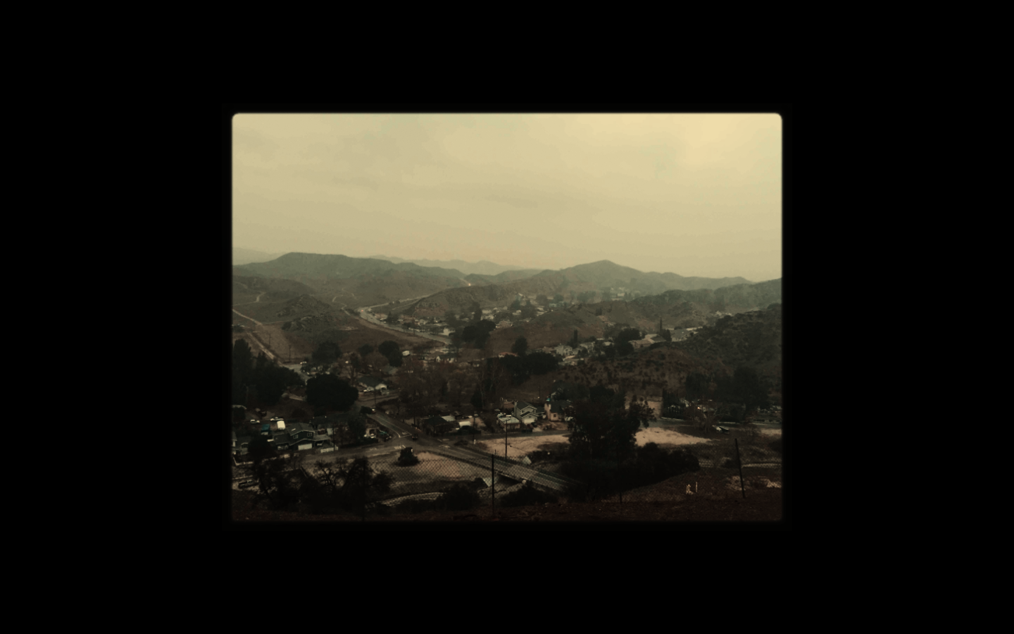

Figure . A photograph of Val Verde, filtered and resized by a Processing sketch.

The piece then progresses as the lecturer speaks about the relational aspect of their work and how it relates to their personal relationships, all while progressing through a collection of slides. It explores the concept of ‘the personal made public’, a concept I later discovered in Maggie Nelson’s *The Argonauts.* The *magic* of the piece is in its final slide, which at first seems to be a slide, but reveals to be a video after the ‘photograph’ begins moving. This ‘novel use of familiar tech’ is the frustration of expectations setup by the illusion of old technology.

### *Kill* *the Magic*

*Kill the Magic* involves the exploration of a system of Arduinos with custom designed LED PCBs (named Puck) by the means of two transistor microphones The sound of the electronics is picked up by the transistor microphones, which act as a means to control the piece’s progression (the same method that *Animal* and *Beast* use to progress their narrative).

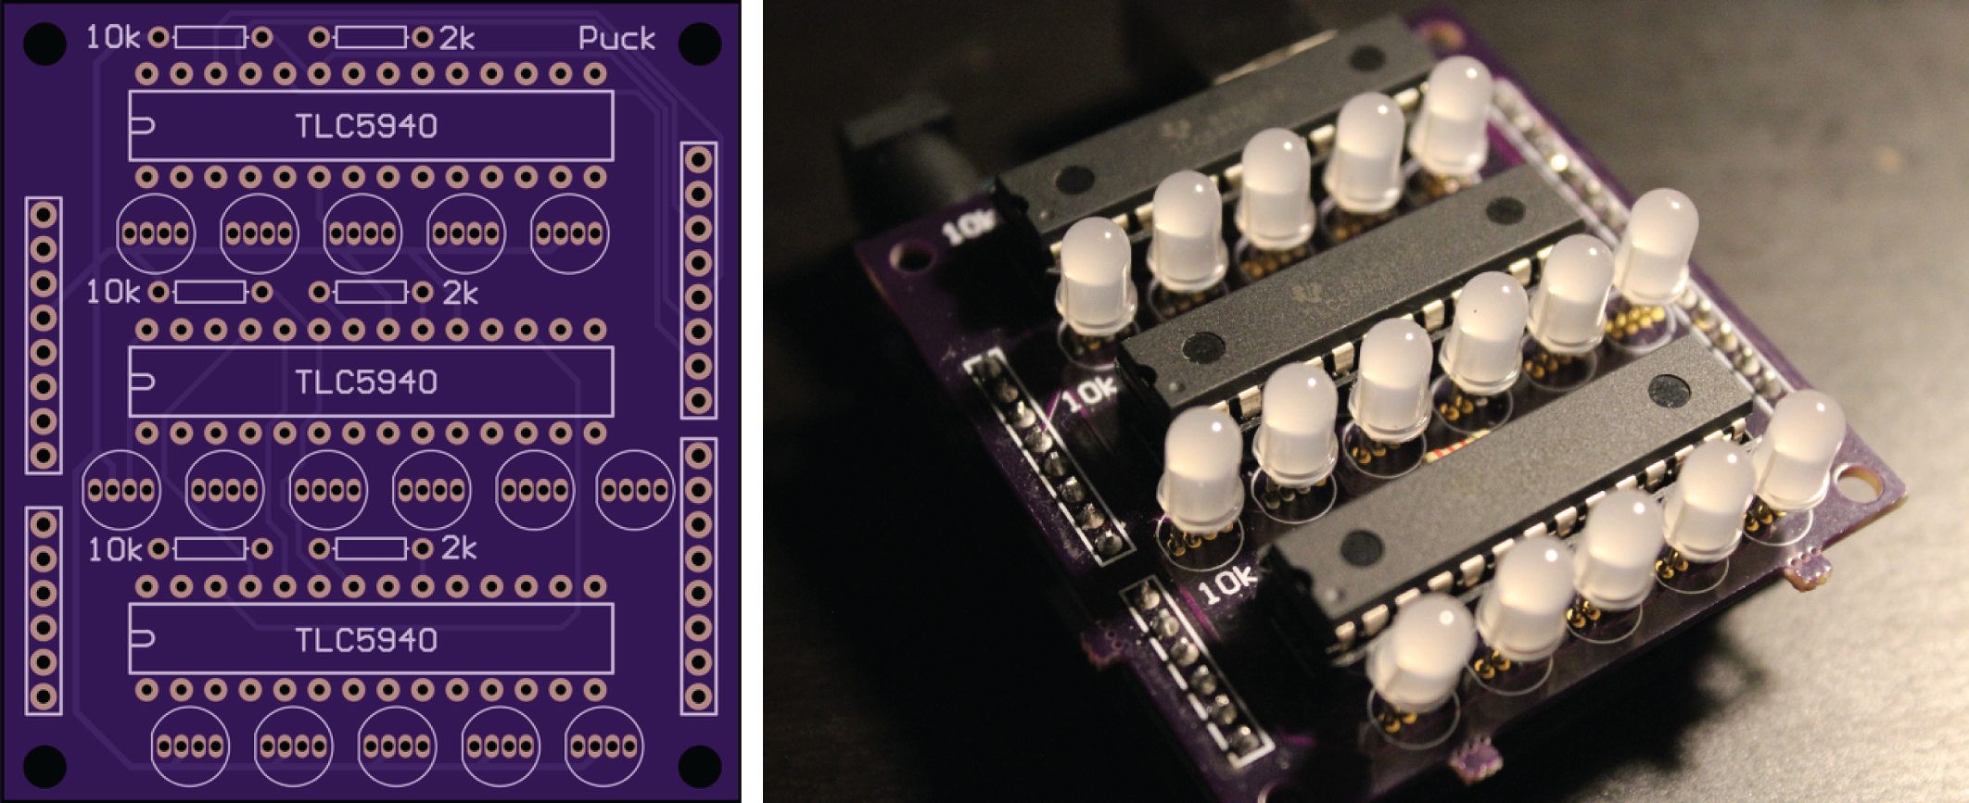

Figure . Puck PCB, allows control of 16 RGB LEDs, (also named after a Dota character).

This piece is partially a lecture performance that describes the development of the piece as it unfolds. The concept of the piece is exactly as the name describes, it is an attempt to ‘kill the magic’ of the piece by explaining its abstract narrative as it develops. The program notes of the piece follow.

I was talking to a good friend last night, and she mentioned (I'm paraphrasing badly) that "magic exists when there is no magic to begin with." Or was it more something like "even though we know that there is no magic occurring, that doesn't mean that it's not magical.”

So I'm going to take that to the extreme with this performance, with a sort of theatrical *Bladerunner* narration (as opposed to the narration-less director's cut, which is empirically better). I might even flip a coin to see which version I perform. I might play a song by The Crystals at the end of it, who knows?

The research in this thesis explains the method in which a *magic trick* can be created in the framework of mechatronic art. *Kill the Magic,* instead,sets up a system of interactions from which a *magic* can be created, but attempts to deny it by explaining the trick behind it.

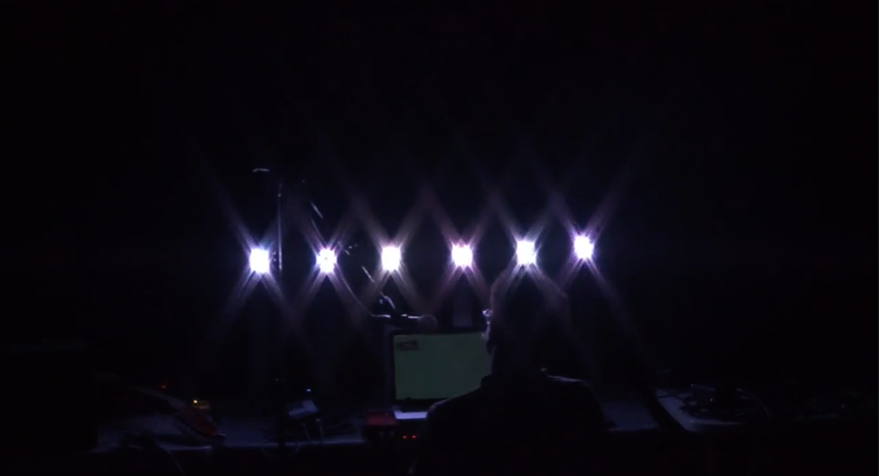

Figure . *Kill the Magic,* performed during ESP night at CalArts in the ROD.

The concept of the piece proves false; while the piece was somewhat successful in fielding questions about magic, the piece failed to kill the magic.

### *Meatbag*

I’ve recently started work on a piece called *Meatbag,* which is a spiritual successor to *Beast*. The major difference, is that *Meatbag* replaces the mechatronic object with a human. The work seeks to continue relationship created in *Beast,* while retaining the tension created in *Beast.*

The piece uses the same slide projector sketch used in *Working On My Thesis* to create an illusion of old technology, but instead uses the projection as a means to communicate a set of rudimentary instructions to the performer.

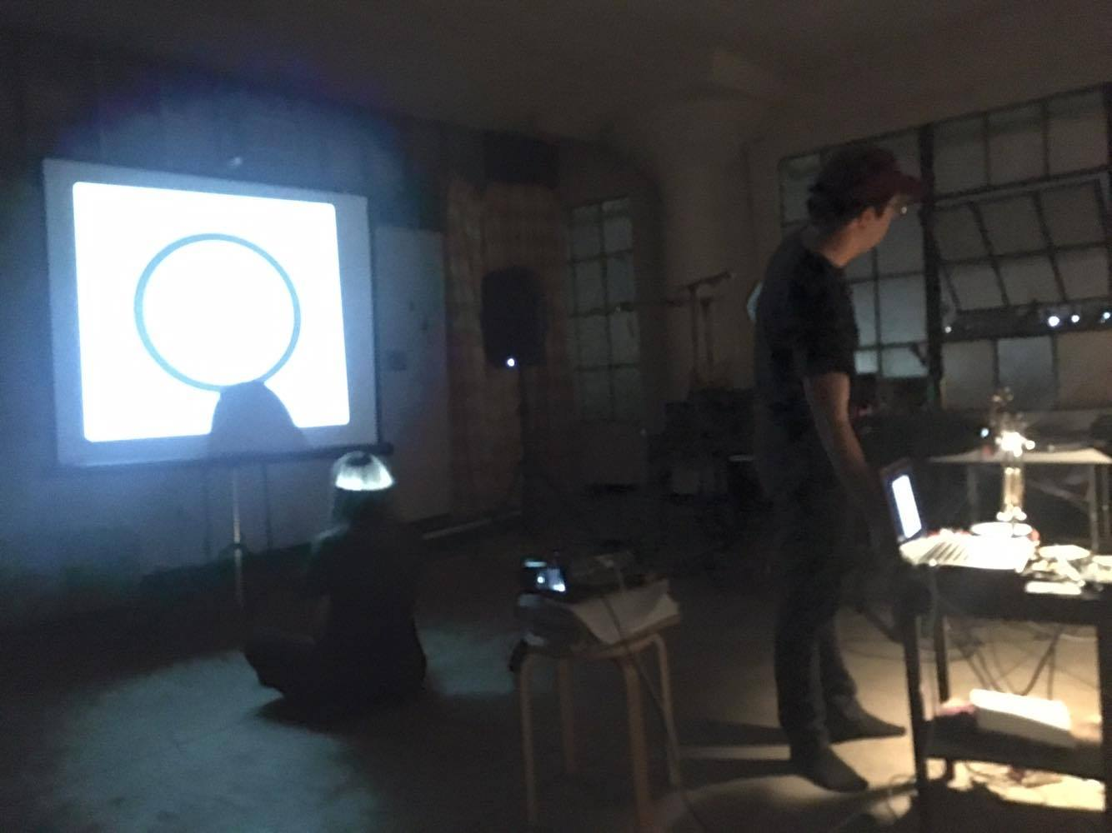

Figure . *Meatbag*, performed at the wulf with Amy Golden.

The ‘object’ in this piece is the other performer, and is treated as such. This piece confronts the abusive nature of *Beast,* as the performer throws chalk at the object, impatiently instructs her to mimic the designs on the screen, and becomes frustrated at her inability to keep up with the instructions given.

This piece is still being developed, but does well to create a relationship between the two performers. In a certain light, it can be seen as transgressive work. In the concert where it was presented, it was programmed to follow *Beast,* so a narrative was continued that replicated the tension between the machine and the performer. The main difference in *Meatbag* is that the piece focuses on the abusive relation between the two performers, with the performers leaving the piece ultimately frustrated with each other.

### Future Work

Future work will continue on the relational aspect of art in this thesis. Different technologies will be utilized, but the goal of that work will continue to be the development of relationships between machines and humans, humans and humans, or even machines and other machines.

## Final Thoughts

This research is an exploration of the work created in the last semester of my time at CalArts, and hopefully will inform my art further. A colleague (Cordey Lopez) mentioned that the process of writing his thesis allowed him to see his art from the ‘outside-in’, meaning that he discovered the conceptual insight of his work after it was created. This is definitely the case in my art as well, and I hope that the writing of this thesis will allow me to create work from the ‘inside-out.’ Instead of creating work and then justifying it, I will now be able to create a conceptual framework before creating my art.

I will continue to create work that explores methods that attempt to infuse human elements into a technologically driven practice, in the hopes that this process will provide insight into the relations I encounter in the ‘real world’.

All of the work contained in this thesis is documented on my website, [www.ericheep.com](http://www.ericheep.com), and all of the code is stored on my GitHub, <https://github.com/ericheep>. The PCB designs and Arduino software are also freely available; the PCB designs are available as a ZIP file that can be uploaded directly to OshPark’s website, www.oshpark.com, for immediate production.

# Bibliography

Ashley, Robert, Federico Marulanda, Achim Wollscheid, and William Marotti. *Yasunao Tone: Noise Media Language*. Edited by Dasha Dekleva and Hans-Ulrich Obrist. Los Angeles, Calif.: Errant Bodies Press, 2006.

Bennett, Jane. *Vibrant Matter: A Political Ecology of Things*. Durham: Duke University Press Books, 2010.

“blog@hf7y --- Zachary Viet Pine.” Accessed July 13, 2016. https://www.ocf.berkeley.edu/~pine/blog/.

Cage, John. *Silence: Lectures and Writings*. Middletown, Conn.: Wesleyan University Press, 1961.

Collins, Nicolas. “Composers Inside Electronics: Music after David Tudor.” *Leonardo Music Journal* 14 (2004): 1–3.

Feldman, Morton. *Sound, Noise, Varese, Boulez*. New York, N.Y.: Second Half Pub., 1958.

Focke, Anne, ed. *Trimpin: Contraptions for Art and Sound*. Seattle Wash.: Marquand Books, 2011.

“‘Full Metal Jacket’: The Jungian Thing (David Louis Edelman).” Accessed July 13, 2016. http://www.davidlouisedelman.com/film/full-metal-jacket/.

Hendren, Sara. “Sara Hendren on Twitter.” *Twitter*. Accessed June 16, 2016. https://twitter.com/ablerism/status/740287638012186624.

Kafka, Franz, and John Updike. *Franz Kafka: The Complete Stories*. Edited by Nahum N. Glatzer. Reprint edition. New York: Schocken Books Inc., 1995.

Kapur, Ajay. “A History of Robotic Musical Instruments.” *Proceedings of the International Computer Music Conference*, 2005, 21–28.

Kubrick, Stanley. *Full Metal Jacket*. Drama, War, 1987.

LaBelle, Brandon. *Background Noise: Perspectives on Sound Art*. New York: Bloomsbury Academic, 2006.

Lucier, Alvin. “Origins of a Form: Acoustical Exploration, Science and Incessancy.” *Leonardo Music Journal* 8 (1998): 5–11. doi:10.2307/1513391.

Mertens, Wim, and Michael Nyman. *American Minimal Music*. New edition. London; White Plains, NY: Kahn & Averill Publishers, 1988.

Murphy, Jim, Ajay Kapur, and Dale Carnegie. “Musical Robotics in a Loudspeaker World: Developments in Alternative Approaches to Localization and Spatialization.” *Leonardo Music Journal* -, no. 22 (November 7, 2012): 41–48. doi:10.1162/LMJ_a_00090.

Nyman, Michael, and Brian Eno. *Experimental Music: Cage and Beyond*. 2 edition. Cambridge ; New York: Cambridge University Press, 1999.

Ostertag, Bob. *Creative Life: Music, Politics, People, and Machines*. 1st Edition edition. Urbana: University of Illinois Press, 2009.

———. “Human Bodies, Computer Music.” *Leonardo Music Journal* 12 (2002): 11–14.

Reich, Steve. *Steve Reich: Writings About Music*. First Edition edition. Halifax; New York: Art Metropole, 1974.

Ross, Alex. *The Rest Is Noise: Listening to the Twentieth Century*. Reprint edition. New York: Picador, 2008.

Russolo, Luigi. *The Art of Noises*. Pendragon Pr, 2005.

Schipper, Jonathan. “Slow Motion Car Crash.” *Jonathan Schipper*. Accessed July 7, 2016. http://www.jonathanschipper.com/.

Singer, Eric, Jeff Feddersen, Chad Redmon, and Bil Bowen. “LEMUR’s Musical Robots.” *Proceedings of the 2004 Conference on New Interfaces for Musical Expression*, 2004, 181–84.

“The Kubrick Site: The Jungian Thing: Duality in Full Metal Jacket.” Accessed July 13, 2016. http://www.visual-memory.co.uk/amk/doc/0093.html.

VanDerWerff, Todd. “Mad Men: ‘The Wheel.’” *A.V. Club*, March 12, 2014. http://www.avclub.com/tvclub/mad-men-wheel-202099.

Vidani, Peter. “092. Nelmarie Du Preez.” *Traction Magazine*. Accessed July 9, 2016. http://tractionmagazine.co.uk/post/123565464761/092-nelmarie-du-preez.

Weiner, Matthew. “The Wheel.” *Mad Men*. American Movie Classics (AMC), October 18, 2007.

Zareei, Mo, Ajay Kapur, and Dale Carnegie. “Rasper: A Mechatronic Noise-Intoner.” *Proceedings of the 2014 Conference on New Interfaces for Musical Expression*, 2014. https://nime2014.sched.org/event/RIc7l9/rasper-a-mechatronic-noise-intoner.

1. Weiner, “The Wheel.”
2. VanDerWerff, “Mad Men.”
3. Hendren, “Sara Hendren on Twitter.”
4. Russolo, *The Art of Noises*.
5. LaBelle, *Background Noise*.
6. Zareei, Kapur, and Carnegie, “Rasper: A Mechatronic Noise-Intoner.”
7. Singer et al., “LEMUR’s Musical Robots.”
8. Kapur, “A History of Robotic Musical Instruments.”
9. Focke, *Trimpin*.
10. Murphy, Kapur, and Carnegie, “Musical Robotics in a Loudspeaker World.”
11. Zareei, Kapur, and Carnegie, “Rasper: A Mechatronic Noise-Intoner.”
12. Ibid.
13. Feldman, *Sound, Noise, Varese, Boulez*.
14. Russolo, *The Art of Noises*.
15. Ross, *The Rest Is Noise*.
16. Ibid.
17. Cage, *Silence*.
18. Reich, *Steve Reich*.
19. Cage, *Silence*.
20. Nyman and Eno, *Experimental Music*.
21. Reich, *Steve Reich*.
22. Mertens and Nyman, *American Minimal Music*.
23. Ibid.
24. Ashley et al., *Yasunao Tone*.
25. Collins, “Composers Inside Electronics: Music after David Tudor.”
26. Ibid.
27. Lucier, “Origins of a Form.”
28. Ibid.
29. Kafka and Updike, *Franz Kafka*.
30. Bennett, *Vibrant Matter*.
31. Ashley et al., *Yasunao Tone*.
32. Schipper, “Slow Motion Car Crash.”
33. Ostertag, “Human Bodies, Computer Music.”
34. Ibid.
35. Ibid.
36. Ibid.
37. Ostertag, *Creative Life*.
38. Ibid.
39. This example illustrates how to create a first-order Markov chain. *Beast’s* rhythms are created using second-order Markov chains, which considers two successive inputs per output instead of only one input.
40. Vidani, “092. Nelmarie Du Preez.”
41. Kubrick, *Full Metal Jacket*.
42. “The Kubrick Site: The Jungian Thing: Duality in Full Metal Jacket.”
43. “‘Full Metal Jacket’: The Jungian Thing (David Louis Edelman).”
44. Ibid.
45. “blog@hf7y --- Zachary Viet Pine.”